

Stakeholder Engagement Strategy



# **Introduction**

The Office of the Federal Safety Commissioner (OFSC) is committed to working with a broad range of stakeholders with the primary objective of improving work health and safety outcomes in the Australian building and construction industry.

In doing so the OFSC recognises the vital role its stakeholders play in supporting and shaping the actions that the Federal Safety Commissioner takes to plan and implement a range of initiatives to drive better safety outcomes on worksites and ensure building and construction industry workers go home safely at the end of each day.

The OFSC acknowledges the importance of adopting a tripartite approach to its stakeholder engagement and the crucial role the building and construction industry plays through its participation in industry collaborations, knowledge sharing and disseminating safety messages across industry.

# **Purpose**

The OFSC Stakeholder Engagement Strategy (the Strategy) is underpinned by:

* relevant legislation including the *Federal Safety Commissioner Act 2022*, *Federal Safety Commissioner (Accreditation Scheme) Rules 2023*, and the *Work Health and Safety Act 2011*;
* the Australian Work Health and Safety Strategy 2023 – 2033, developed by Safe Work Australia
* the Department of Employment and Workplace Relations Corporate Plan; and the
* Ministerial Statement of Expectations for the Federal Safety Commissioner, as issued by the Minister for Workplace Relations, and the Federal Safety Commissioner’s Statement of Intent.

The Strategy is guided by the APS Regulator Performance Framework, APS Framework for engagement and participation (including the Charter of Partnerships and Engagement) and is supported by internal policies and procedures. The Strategy informs the OFSC’s stakeholder engagement plan.

The OFSC’s Stakeholder Engagement Strategy outlines the principles and approach used by the OFSC to inform its approach to stakeholder engagement, identifies key stakeholder groups, provides a summary of the engagement process including methods of engagement, and how this guides the OFSC’s operational plan.

# **Background**

The OFSC is a small regulator that promotes work health and safety in the building and construction industry across Australia. It is responsible for administering the WHS Accreditation Scheme, promoting the benefits of the Scheme and disseminating this information to industry. In doing so the OFSC relies on the distribution of Commonwealth funding as a policy lever to improve work health and safety practices across the building and construction industry.

In recognition of the constant changes faced by industry and the evolving work health and safety landscape, including the emergence of new hazards and new technologies, the OFSC acknowledges the importance of establishing a Stakeholder Engagement Strategy that involves range of stakeholders. Importantly the OFSC acknowledges the benefits in adopting a tripartite approach to stakeholder engagement and valuing the differing perspectives of stakeholders, including community and social partners, all who have the same goal in mind of reducing the number of fatalities and injuries in the industry.

The intent of the Stakeholder Engagement Strategy is to promote transparency and guide the OFSC’s modern approach in engaging in genuine dialogue with traditional and non-traditional stakeholders and the broader community, including industry representatives, academia and work health and safety regulators at both the Commonwealth and state/territory level.

The OFSC Leadership team, FSC Industry Reference Group and other key stakeholders have been consulted on the Strategy and their feedback incorporated.

# **Principles for engagement**

The OFSC engages, consults and collaborates with a wide range of stakeholders at the strategic and operational level to achieve our overarching objective of promoting and driving safety outcomes in the building and construction industry. In doing so, the OFSC is guided by the 4 C’s:

1. **Communicate** – the OFSC communicates with all stakeholders in an open and transparent manner, and recognises the benefits associated with adhering to a tripartite approach to stakeholder engagement.
2. **Consider** – the OFSC actively listens, is responsive to feedback, and engages in genuine dialogue with stakeholders.
3. **Collaborate** – the OFSC actively seeks out opportunities to collaborate and partner with industry to improve WHS education and awareness across entire industry, for the benefit of both Scheme and non-Scheme accredited builders.
4. **Connect** – the OFSC connects and engages with key stakeholders by adopting a case management style approach. This involves assigning a relationship manager, that is an OFSC official, to be the primary contact for our stakeholders, such as government agencies, worker representatives and social partners. The level and frequency of engagement will be determined following an assessment by the OFSC taking into consideration importance, resourcing and key priorities of the Federal Safety Commissioner and Government.

In adhering to the principles outlined above, the OFSC seeks to communicate, consider, collaborate, and connect with our traditional and non-traditional stakeholder in a manner that promotes the WHS Accreditation Scheme and its benefits, shares knowledge, expertise and best practice for the benefit of the industry as a whole, and builds a culture based on continuous improvement.

# **Identifying our stakeholders**

The OFSC works with industry and government stakeholders towards achieving the highest possible WHS standards on building and construction sites across the nation. The OFSC engages with people who have an interest in what we do and who are connected to our purpose. At the core of how the OFSC operates and measures success are our stakeholders, and we recognise that the quality of these stakeholder relationships is important to how well we deliver on our vision for a safe and healthy building and construction sector.

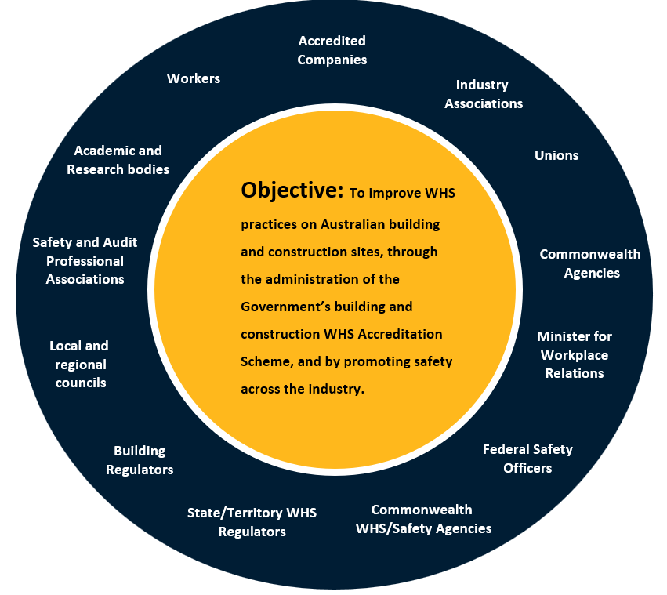

# **OFSC values**

As outlined above, the purpose and objective of the OFSC is to: promote and drive safety outcomes across the Australian building and construction industry by using Commonwealth procurement as a lever for change, to ensure every worker goes home safely at the end of each day.

The OFSC achieves this through providing pre-accreditation support for new applicants including small business, administering the WHS Accreditation Scheme and conducting audits to ensure compliance with the Scheme, Scheme Governance and Assurance underpinned by a data-driven approach, engagement and industry collaborations with a broad range of stakeholders, and providing education and outreach activities.

In engaging with its stakeholders and performing its legislated functions, the OFSC is guided by the following values:

# **Process for shaping our Stakeholder Engagement Plan**

At the start of each financial year, the Federal Safety Commissioner and OFSC Leadership team will determine its key priorities for the forthcoming year.

As part of this process, the OFSC will gather existing data and information on stakeholder engagement over the preceding year, and map existing feedback obtained from various sources including from the FSC Annual Census. The OFSC will also identify certain interest groups based on Government policies, programs and/or major construction projects, and current and emerging issues, and having then determined who to engage, the OFSC will then assess the stakeholder’s level of influence and level of interest to determine the appropriate level at which to engage as well as frequency and format of stakeholder meetings. The outcome of this process will then inform the OFSC’s Stakeholder Engagement Operational Plan.

# **Methods of engagement**

The OFSC engages with its broad range of stakeholders in different ways, including through roundtables on specific topics, collaborations on safety best practice, through the website [www.fsc.gov.au](http://www.fsc.gov.au), the FSC Online portal and a social media presence.

Through a relationship manager approach, the OFSC will assign a relationship manager to each group of stakeholder/s who will act as the main point of contact for that individual or stakeholder group. This will assist the OFSC to take a tailored approach to its stakeholder relationships, to ensure it continues to be responsive, collaborative and connected.

# **Regular reviews of this Strategy**

In recognition of the dynamic environment in which the OFSC operates within, this Strategy will be regularly reviewed to ensure it remains current and fit for purpose. The Strategy may be updated from time to time as necessary taking into account current and emerging issues as well as any shifts in priorities for the Federal Safety Commissioner and/or Commonwealth Government.

At a minimum the Strategy will be reviewed annually and will be informed by feedback received from internal and external stakeholders. The Strategy will then inform the OFSC’s Stakeholder Engagement Operational Plan over the next year.