

Federal Safety Commissioner

Annual Data Report

2023

# Contents

Contents 2

Overview 3

Data source 4

Accreditation Scheme 5

Accredited Companies 5

Injury rates over time 8

Workers’ Compensation Premium Rates over time 9

Scheme Audits 10

Audit Overview 10

Map of Scheme Audit Locations During 2023 10

Audit Breakdown 11

Corrective Action Report Breakdown 12

Audit Head Criteria Issue Rates 13

Audit Sub-criteria Issue Rates 14

Scheme Reporting 18

Fatalities 18

Injury Frequency Rates 18

Lost Time Injuries 18

Medically Treated Injuries 19

Fatality Frequency Rates 20

Nature of Injuries 21

Mechanism of Injuries 22

FSC Annual Census 24

Education 25

Webinars 25

Case Studies 26

Collaborations 27

Glossary 28

# Overview

The Federal Safety Commissioner (FSC) and their Office (OFSC) act to improve workplace health and safety (WHS) practices on building and construction sites across Australia. We do this through the administration of the Australian Government Work Health and Safety Accreditation Scheme (the Scheme) and by promoting safety across the industry.

There are over 570 accredited companies in Australia performing commercial, civil and residential building and construction projects. These companies are eligible to be contracted for projects funded by the Australian Government, and benefit from improved WHS performance, and reduced insurance and workers’ compensation costs.

Accredited companies are subject to an ongoing, on-site audit program. These on-site audits provide the Government and the community with assurance that the construction work being undertaken by accredited companies is being carried out to the highest of safety standards. Pages 10-17 of this report address some results and trends of the Scheme audit program during calendar year 2023.

A condition of accreditation is that accredited companies comply with the reporting requirements of the Scheme. Accredited companies are required to provide information to the OFSC on their WHS performance, including incident reports, hours worked and workers' compensation premium rates. Data and analysis from this information is available throughout this report, with specific incident reporting data found in pages 18-23.

The OFSC conducts a voluntary, anonymous census on Scheme accredited companies every year, with on average approximately two-thirds of accredited companies responding in recent years. Outcomes of the 2023 FSC Annual Census are on page 24.

A key function of the Federal Safety Commissioner is the promotion of WHS in relation to building work. On-site audits and reporting on WHS performance enables the OFSC to assess the impact of the Scheme on industry safety, the ongoing suitability of companies to remain accredited under the Scheme, and to determine WHS trends and benchmarks. This in turn allows the OFSC to provide relevant, useful best practice advice to aid in the improvement of WHS awareness and culture in the building and construction industry. The OFSC produce a range of educational resources targeting these identified key safety issues. The ongoing production of resources include WHS Webinars, Case Studies, Fact Sheets, Checklists and various safety data reports, shown on pages 25-27.

# Data source

The data presented in this report has been sourced from STORM - Federal Safety Commissioner Data Asset. This data asset contains WHS and Scheme related information:

* provided by accredited companies and collected by the Department of Employment and Workplace Relations, and
* generated by the Department of Employment and Workplace Relations

The data presented in this report is of 31 December 2023, or as otherwise indicated.

# Accreditation Scheme

## Accredited Companies

At the end of the 2023 calendar year, 572 individual companies held accreditation by the Federal Safety Commissioner (FSC) under the Work Health and Safety Accreditation Scheme (the Scheme).

There was a net increase in accredited companies of 11 to 572 companies from 561 companies in 2022, taking into account new accreditations, and accreditations that expired, were withdrawn or were suspended.

The 572 individually accredited companies made up 433 accreditations. Nineteen per cent of accreditations comprised two or more companies. Jointly accredited companies are counted as one accreditation in Table 1 below and throughout this report. The net number of accreditations increased by six to 433 accreditations at 31 December 2023, from 427 accreditations at 31 December 2022.

During the 2023 calendar year, the Federal Safety Commissioner approved 29 new accreditations based on applications received in 2023 and past calendar years. The annual average number of new accreditations over the past five calendar years is 33.

#### **Table 1: Number of Accreditations and Companies, 2019-23 (as of 31 December 2023)**

|  |  |  |  |  |  |
| --- | --- | --- | --- | --- | --- |
| **Calendar Year** | **2019** | **2020** | **2021** | **2022** | **2023** |
| **Accreditations** | 383 | 409 | 426 | 428 | 433 |
| **Companies** | 515 | 542 | 565 | 561 | 572 |

#### **Figure 1: New and ongoing accreditations, 2019-23**

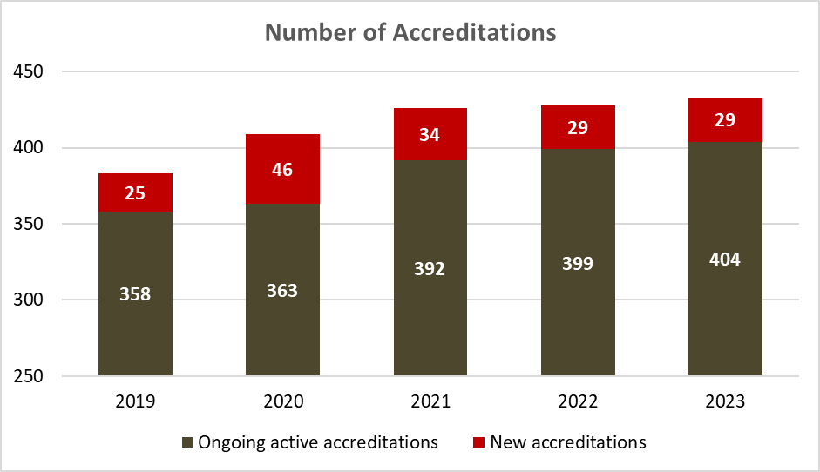

**Indigenous businesses**

As of 31 December 2023, 32 accredited companies reported they were Indigenous owned businesses. Indigenous owned businesses make up approximately six per cent of all accredited companies.

**Accreditations by Size by Capability**

The majority of Accreditations (single and joint) report that they undertake civil and commercial construction and are medium to large employers.

#### **Table 2: Number of accreditations by company size by construction type**

|  |  |  |  |
| --- | --- | --- | --- |
| **Size** | **Civil** | **Commercial** | **Residential** |
| Large (200+ employees) | 86 | 72 | 26 |
| Medium (20-199 employees) | 161 | 159 | 59 |
| Small (less than 20 employees) | 35 | 43 | 13 |
| **Total accreditations** | **282** | **274** | **98** |

**Note:** Accredited companies can undertake more than one type of construction, hence these totals are not additive.

**Accreditations by Capability by State**

Accreditations (single and joint) can operate in more than one State and Territory. Table 3 depicts the construction capability (i.e. civil, commercial and residential) and area of operation reported at the accreditation level.

#### **Table 3: Number of accreditations by state/territory by construction type**

|  |  |  |  |
| --- | --- | --- | --- |
| **State** | **Civil** | **Commercial** | **Residential** |
| NSW | 213 | 201 | 68 |
| VIC | 170 | 159 | 42 |
| QLD | 208 | 169 | 53 |
| WA | 158 | 135 | 41 |
| SA | 148 | 127 | 36 |
| TAS | 118 | 94 | 23 |
| NT | 157 | 126 | 48 |
| ACT | 156 | 152 | 49 |
| **Total accreditations** | **282** | **275** | **100** |

**Note:** Accredited companies can undertake more than one construction type across multiple states/territories, hence these counts are not additive in either direction.

**Scheme projects**

Building commenced on 143 new Scheme projects (refer Glossary for description) in 2023. These new projects make up just over one quarter of the 559 Scheme projects that were active during 2023. The 559 Scheme projects active during 2023 had a combined value of $102 billion. Table 4 and Figure 2, below and over the page, provide the number of projects active during the last five years.

#### **Table 4: Number of active scheme projects, 2019-23**

|  |  |  |  |  |  |  |
| --- | --- | --- | --- | --- | --- | --- |
| **Calendar Year** | **2019** | **2020** | **2021** | **2022** | **2023** | **5-year average** |
| **Total Active Scheme Projects** | 458 | 470 | 533 | 589 | 559 | 522 |

#### **Figure 2: New Scheme Projects vs Ongoing Scheme Projects, 2019-23**

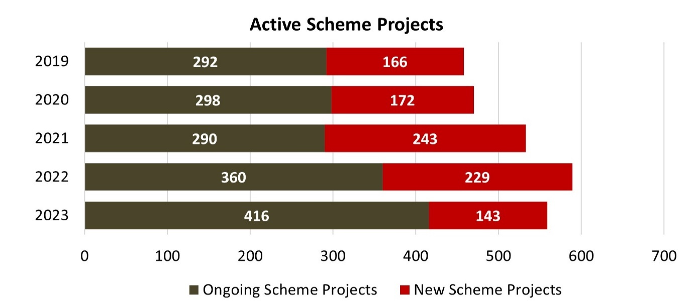

As of 31 December 2023, accredited companies had been head contractor on 2,835 Scheme projects since the Scheme began in 2006. These projects have had a combined value of $226.5 billion. Table 5 and Figure 3 show the total number of Scheme projects and their combined value by calendar year.

#### **Table 5: Total number of Scheme projects and value ($), 2019-23**

|  |  |  |  |  |  |
| --- | --- | --- | --- | --- | --- |
|  | **2019** | **2020** | **2021** | **2022** | **2023** |
| **Total Scheme Projects** | 2,048 | 2,220 | 2,463 | 2,692 | 2,835 |
| **Value (Billions)** | $134 | $148 | $167 | $198 | $227 |

**Note:** Figures are rounded.

#### **Figure 3: Number and value ($bn) of Scheme Projects, 2019-23**

## Injury rates over time

Table 6 and Figure 4 below show an analysis of lost time injury frequency rates (LTIFR) of accredited companies measured at three year intervals in comparison to their LTIFR when first accredited. The analysis shows that:

* after three years of accreditation, 47 per cent of companies reduced their LTIFR by an average of 77 per cent.
* after six years this increased to 60 per cent of companies having reduced their LTIFR by an average of 88 per cent.
* after nine years, 71 per cent of companies had reduced their LTIFR by an average of 92 per cent.
* after 12 years, 76 per cent of companies had reduced their LTIFR by an average of 96 per cent.
* finally, after 15 years, 87 per cent of companies had reduced their LTIFR by an average of 88 per cent.

#### **Table 6: Analysis of LTIFR change over time (3-15 years)**

|  |  |  |  |  |  |
| --- | --- | --- | --- | --- | --- |
|  | **Years Accredited under the Scheme** | | | | |
|  | **3 years** | **6 years** | **9 years** | **12 years** | **15 years** |
| **Accredited Companies with Improved LTIFR** | 47% | 60% | 71% | 76% | 87% |
| **Average Improvement to LTIFR** | 77% | 88% | 92% | 96% | 88% |

**Note:** Figures are rounded. Where available, the baseline LTIFR is based on all of the companies’ works on application, otherwise the first biannual data submission is used as the baseline. All of the subsequent time periods are based on projects where they are the head contractor.

#### **Figure 4: Accredited companies’ Lost Time Injury Frequency Rate over time**

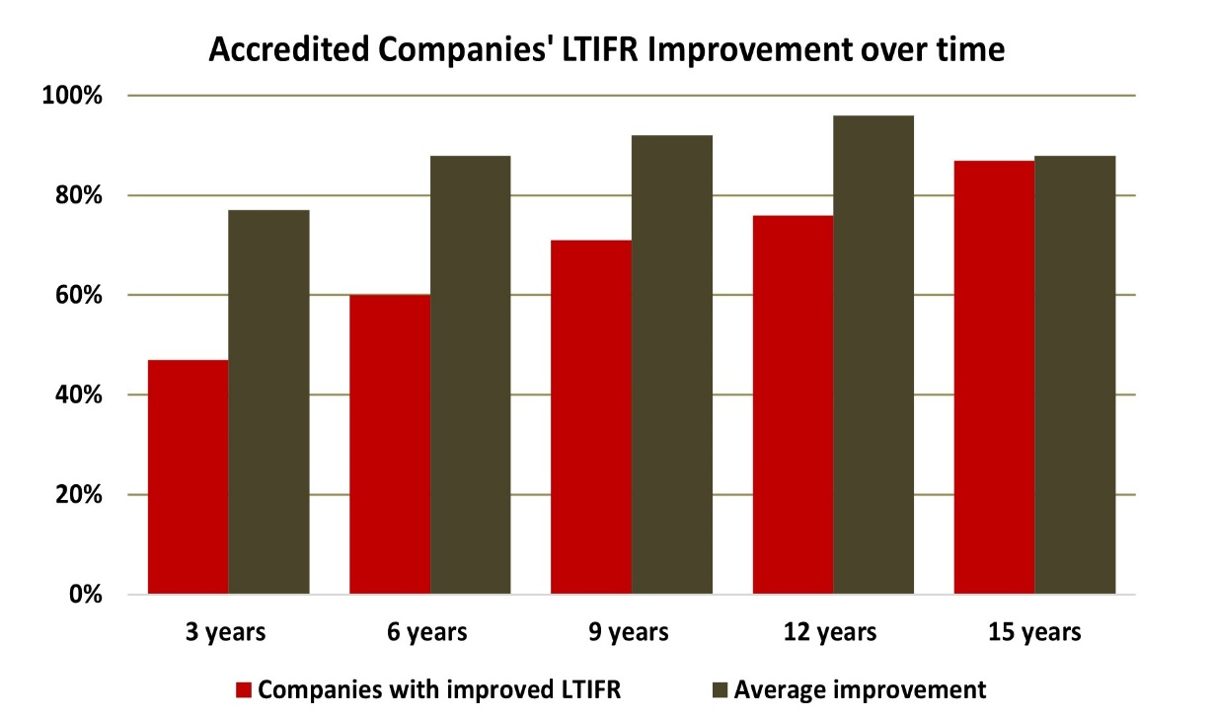

## Workers’ Compensation Premium Rates over time

Table 7 and Figure 5 below show the changes to Scheme accredited companies Workers’ compensation premium rates (WCPR) over time.

* After three years of accreditation, 58 per cent of companies reduced their WCPR by an average of 34 per cent.
* After six years this has increased to 60 per cent of companies having reduced their WCPR by an average of 38 per cent.
* After nine years, 68 per cent of companies reduced their WCPR by an average of 44 per cent.
* This WCPR reduction increases again after 12 years, with 70 per cent of companies reducing their WCPR by an average of 50 per cent.
* After 15 years, 83 per cent of companies reduced their WCPR by an average of 49 per cent.

#### **Table 7: Analysis of WCPR change over time (3-15 years)**

|  |  |  |  |  |  |
| --- | --- | --- | --- | --- | --- |
|  | **Years Accredited under the Scheme** | | | | |
|  | **3 years** | **6 years** | **9 years** | **12 years** | **15 years** |
| **Accredited Companies with Improved WCPR** | 58% | 60% | 68% | 70% | 83% |
| **Average Improvement to WCPR** | 34% | 38% | 44% | 50% | 49% |

**Note:** Figures are rounded.

#### **Figure 5: Accredited companies’ Workers Compensation Premium Rate over time**

# Scheme Audits

## Audit Overview

Scheme accredited companies undergo regular on-site safety audits as a requirement of accreditation. These audits are conducted by Federal Safety Officers (FSOs) against the FSC Audit Criteria. Company audit performance informs the OFSC risk management approach, which guides the frequency and focus of future audits and potential compliance action. Figure 7 below shows a map of the 2023 on-site OFSC audit locations.

## Map of Scheme Audit Locations During 2023

#### **Figure 7: Map of on-site OFSC Audit Locations, 2023**

The OFSC conducted 552 safety audits in 2023 across 769 days on-site testing compliance with 13,992 audit sub-criteria. Arising from these audits:

* 3,154 Corrective Action Reports (CARs) were issued - a compliance rate of 77.5%,
* 22 per cent of CARS were classified as Major CARs (690), and
* 78 per cent were classified as Minor CARs (2,464)

The number of OFSCs Audits and on-site audit days by year is provided in Table 8 below.

#### **Table 8: Number of OFSC Audits and on-site audit days, 2019-23**

|  |  |  |  |  |  |
| --- | --- | --- | --- | --- | --- |
|  | **2019** | **2020** | **2021** | **2022** | **2023** |
| **Audits** | 428 | 404 | 452 | 526 | 552 |
| **Audit days on-site** | 573 | 561 | 625 | 750 | 769 |

## Audit Breakdown

On-site audits assess the WHS Management System (WHSMS) implementation of companies applying for Scheme accreditation. Once accredited, it is a requirement of maintaining accreditation to also undergo regular on-site audits. In 2020 the OFSC introduced System Validation Audits (SVAs), which are a desktop audit process conducted prior to the initial pre-accreditation on-site audit to assist applicants in identifying areas of their WHSMS that do not currently meet Scheme standards. This allows applicants to be more prepared before their first on-site audit as they aim to achieve accreditation. This has decreased the number of on-site audits being conducted on applicants and created capacity for more on-site audits of accredited companies. Table 9 and Figure 7 below show the breakdown of OFSC audits by type for the last five years.

#### **Table 9: Breakdown of OFSC Audits by Type, 2019-23**

|  |  |  |  |  |  |
| --- | --- | --- | --- | --- | --- |
|  | **2019** | **2020** | **2021** | **2022** | **2023** |
| **Accredited Company Audits** | 327 | 273 | 325 | 387 | 421 |
| **Non-accredited Company Audits** | 101 | 127 | 99 | 53 | 59 |
| **System Validation Audits\*** | 0 | 4 | 28 | 86 | 72 |

*In 2023, as part of our new database development, a thorough check was conducted on the System Validation Audits totals, resulting in some of the audit totals for previous years being revised.

#### **Figure 7: Breakdown of OFSC Audits by type, 2019-23**

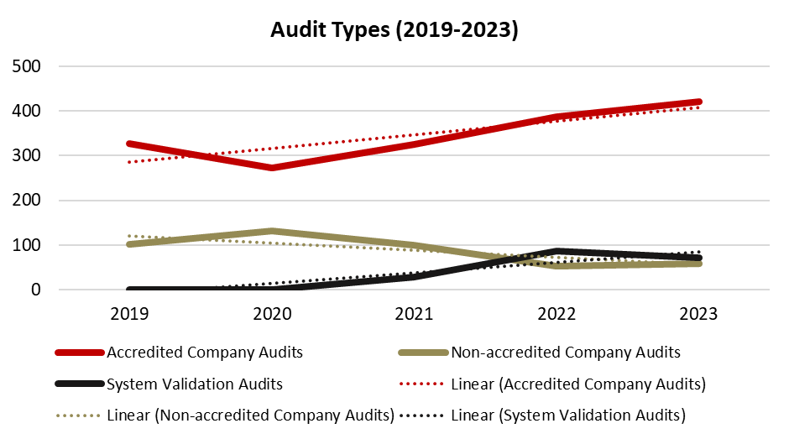

## Corrective Action Report Breakdown

Table 10 and Figure 8 below show the breakdown of Corrective Action Reports (CARs) by type from 2019-23. Following a consistently high total of CARs issued from 2019 to 2021, the total number of CARs in 2022 dropped below 3,000, before rising slightly to 3,154 for 2023. This is due to the impact of the SVAs that assist companies in implementing more robust WHSMS prior to their initial on-site audit. Companies are informed about areas of their WHSMS that do not meet Scheme requirements, but CARs are not issued. The number of CARs issued to accredited companies has increased by 5 and 28 per cent for major and minor respectively since 2021. Due to SVAs, non-accredited companies’ CARs have dropped by 86 and 26 per cent for major and minor respectively from 2021 to 2023.

#### **Table 10: Breakdown of CARs by type, 2019-23**

|  |  |  |  |  |  |
| --- | --- | --- | --- | --- | --- |
|  | **2019** | **2020** | **2021** | **2022** | **2023** |
| **Accredited Major** | 508 | 620 | 530 | 622 | 554 |
| **Accredited Minor** | 1,352 | 1,130 | 1,568 | 1,859 | 2,002 |
| **Non-accredited Major** | 1,521 | 1,196 | 969 | 136 | 136 |
| **Non-accredited Minor** | 731 | 849 | 622 | 352 | 462 |
| **Totals** | **4,112** | **3,795** | **3,689** | **2,969** | **3,154** |

#### **Figure 8: Major and Minor CARs – Accredited vs non-accredited companies, 2019-23**

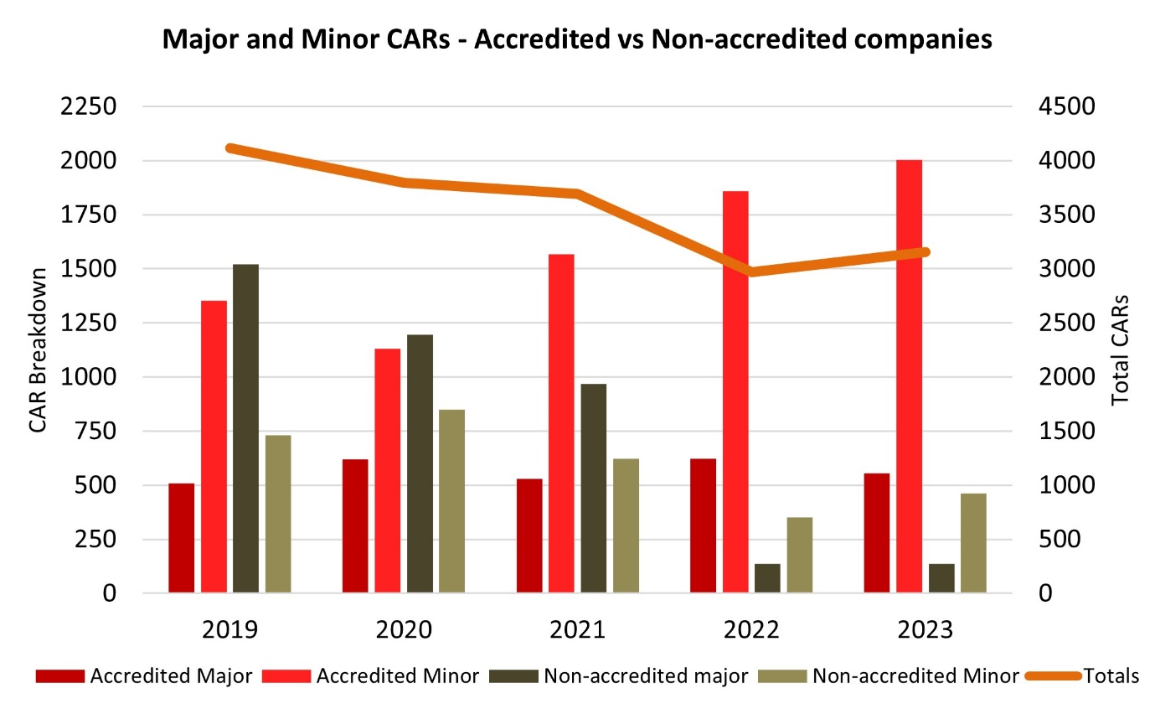

## Audit Head Criteria Issue Rates

Table 11 below displays the five head criteria with the highest CAR issue rates (over 30%). The highest CAR issue rates for audit head criteria across audits on both accredited companies and applicants applying for accreditation related to Health & Safety Management System Auditing, Health Surveillance and Exposure Monitoring and Senior Management Commitment.

#### **Table 11: Highest five Issue Rates (CARs) by Audit Head Criteria for all Audits, 2023**

|  |  |  |  |  |
| --- | --- | --- | --- | --- |
| **Head Criteria** | | **CARs Issued** | **As a percentage of all CARs issued** | **Issue rate as a percentage** |
| **WH17** | **Health & Safety Management System Audit** | 117 | 4 | 39 |
| **WH14** | **Health Surveillance and Exposure Monitoring** | 146 | 5 | 36 |
| **FP1** | **Senior Management Commitment** | 174 | 6 | 34 |
| **WH13** | **Emergency Preparedness and Response** | 323 | 10 | 32 |
| **H14** | **Tilt up/Precast Concrete** | 19 | 1 | 30 |

**Note:** Figures are rounded. Minimum 20 subcriteria tested.

Table 12 below displays the five head criteria with the lowest CAR issue rates. The lowest CAR issue rates for audit head criteria across audits on both accredited companies and applicants applying for accreditation related to Excavation; Construction Work In, Over or Adjacent to Water/Liquids Where Risk Of Drowning; and Confined Spaces.

#### **Table 12: Lowest five Issue Rates (CARs) by Audit Head Criteria for all Audits, 2023**

|  |  |  |  |  |
| --- | --- | --- | --- | --- |
| **Head Criteria** | | **CARs Issued** | **As a percentage of all CARs issued** | **Issue rate as a percentage** |
| **H7** | **Excavation** | 178 | 6 | 17 |
| **FP6** | **Training Arrangements** | 73 | 2 | 17 |
| **H6** | **Confined Spaces** | 5 | 0.2 | 17 |
| **H19** | **Construction Work In, Over or Adjacent to Water/Liquids Where Risk Of Drowning** | 5 | 0.2 | 10 |
| **H3** | **Demolition** | 6 | 0.2 | 8 |

**Note:** Figures are rounded. Minimum 20 subcriteria tested.

## Audit Sub-criteria Issue Rates

Tables 13 and 14 show the sub-criteria CAR issue rates as of 31 December 2023, broken down into applicants who are not accredited but have undergone on-site audits in the process of applying for accreditation, and Scheme accredited builders respectively. Sub-criteria reviewed less than 20 times have been excluded.

* **WH13.7**, which requires a documented process to ensure a competent person identifies emergency equipment and requirements has the highest issue rate for non-accredited companies with an issue rate of 47 per cent, an increase of over 16 per cent from last year.
* **FP3.1**, which requires a documented process for the establishment of WHS consultation, cooperation and coordination arrangements has the highest issue rate CAR for Scheme accredited companies.

#### **Table 13: Ten Highest Issue Rate (CARs) by Audit Sub Criteria for Non-accredited companies applying for Scheme accreditation**

| **Sub criteria** | **Issue rate as a percentage** | **Times issued** | **Times reviewed** |
| --- | --- | --- | --- |
| **WH13.7** There is a documented process to ensure competent person identifies site emergency equipment and requirements. | 47 | 18 | 38 |
| **FP1.3** There is a documented process to ensure senior managers, site managers and supervisors are trained in WHS obligations/due diligence, and the company’s WHS management system requirements relevant to their role. | 45 | 17 | 38 |
| **WH13.6** There is a documented process to ensure a qualified person identifies site first aid equipment and requirements in accordance with relevant legislation, codes of practice and Australian standards. | 45 | 17 | 38 |
| **FP4.2** There is a documented process to ensure HIRAC is applied in subcontractor selection/procurement. | 41 | 16 | 39 |
| **H16.3** Safe systems of work are established for the operation of mobile plant taking into account the operator manual, outcomes from the plant risk assessment, site specific requirements, and the need for ROPS and FOPS. | 41 | 15 | 37 |
| **WH13.4** There is a documented process to ensure designated emergency personnel for the project have been inducted in the site-specific emergency procedures/plans; and have obtained any qualification or formal training defined by the company as required to fulfill the role. | 40 | 15 | 38 |
| **WH13.5** There is a documented process to ensure emergency practice drills are scheduled and carried out on site; are scenario based and test a variety of the identified potential emergency situations; are recorded and evaluated for effectiveness; and incorporate a process for the identification and management of corrective actions. | 40 | 15 | 38 |
| **WH17.3** There is a documented process to ensure that formally trained personnel undertake audits in accordance with the schedule. | 40 | 15 | 38 |
| **FP1.2** There is a documented process to ensure WHS reports are produced that monitor performance against the WHS objectives and targets defined by the organisation; are regularly reviewed by senior management; and are communicated to site management. | 37 | 14 | 38 |
| **WH14.1** There is a documented process to ensure a competent person completes a site-specific assessment of potential health hazards, including biological; physical; and chemical/atmospheric contaminants. | 37 | 14 | 38 |

**Note:** Issue rates are rounded.

#### **Table 14: Ten Highest Issue Rates (CARs) by Audit Sub Criteria for Scheme accredited companies (as of 31 December 2023)**

| **Sub criteria** | **Issue Rate as a percentage** | **Times issued** | **Times reviewed** |
| --- | --- | --- | --- |
| **FP3.1** There is a documented process for the establishment of WHS consultation, cooperation and coordination arrangements, including agreement on the establishment of consultation arrangements with workers on site; consultation with workers or their representatives when WHS issues arise; a program to ensure regular meetings with minutes of the meetings available to all workers; and training for health and safety representatives and WHS committee members where requested or required. | 57 | 33 | 58 |
| **WH14.1** There is a documented process to ensure a competent person completes a site-specific assessment of potential health hazards, including biological; physical; and chemical/atmospheric contaminants. | 55 | 31 | 56 |
| **WH14.2** There is a documented process to ensure that, where identified as required, personal exposure to health hazards is measured and evaluated on the project by a formally trained person. | 49 | 20 | 41 |
| **WH17.2** There is a documented process to ensure that the audit program defines the audit scope, methodology, reporting requirements, and process for identifying and managing corrective actions. | 46 | 26 | 56 |
| **WH17.3** There is a documented process to ensure that formally trained personnel undertake audits in accordance with the schedule. | 46 | 26 | 56 |
| **H5.6** The system ensures that structural support systems and temporary structures are installed by a competent person and verified as correctly installed prior to use in accordance with relevant legislation, codes of practice and Australian standards; manufacturers’ requirements; or where applicable the drawing/plan. | 46 | 40 | 87 |
| **H1.3** Safe systems of work have been developed to ensure fall prevention systems/structures are verified as installed in accordance with the manufacturers’ instructions and relevant legislation, codes of practice and Australian standards; and subject to regular documented inspection as per the relevant legislation, codes of practice and Australian standards. | 46 | 50 | 110 |
| **WH13.5** There is a documented process to ensure emergency practice drills are scheduled and carried out on site; are scenario based and test a variety of the identified potential emergency situations; are recorded and evaluated for effectiveness; and incorporate a process for the identification and management of corrective actions. | 45 | 38 | 84 |
| **H7.6** The system ensures that the excavation is regularly inspected by a competent person to monitor the effectiveness of controls in accordance with the drawing/plan/permit. | 44 | 42 | 95 |
| **WH14.3** There is a documented process to ensure that worker health surveillance/monitoring is carried out in accordance with identified health hazards; is carried out in accordance with relevant legislation, codes of practice and Australian standards; and includes a process for management and communication of health monitoring results and records. | 44 | 18 | 41 |

**Note:** Issue rates are rounded.

From Table 15 below, the sub criteria with the five highest issue rates in 2023 have all trended up from 2019 to 2023.

#### **Table 15: Performance of Subcriteria with the five highest 2023 issue rates (CARs), 2019-2023**

|  |  |  |  |  |  |
| --- | --- | --- | --- | --- | --- |
| **Sub criteria** | **Issue Rates as a percentage** | | | | |
| **2019** | **2020** | **2021** | **2022** | **2023** |
| **FP3.1** There is a documented process for the establishment of WHS consultation, cooperation and coordination arrangements, including agreement on the establishment of consultation arrangements with workers on site; consultation with workers or their representatives when WHS issues arise; a program to ensure regular meetings with minutes of the meetings available to all workers; and training for health and safety representatives and WHS committee members where requested or required. | 55 | 50 | 44 | 54 | 57 |
| **WH14.1** There is a documented process to ensure a competent person completes a site-specific assessment of potential health hazards, including biological; physical; and chemical/atmospheric contaminants. | 34 | 66 | 50 | 47 | 55 |
| **WH14.2** There is a documented process to ensure that, where identified as required, personal exposure to health hazards is measured and evaluated on the project by a formally trained person. | 41 | 36 | 38 | 45 | 49 |
| **WH17.2** There is a documented process to ensure that the audit program defines the audit scope, methodology, reporting requirements, and process for identifying and managing corrective actions. | 30 | 23 | 29 | 44 | 46 |
| **WH17.3** There is a documented process to ensure that formally trained personnel undertake audits in accordance with the schedule. | 35 | 37 | 35 | 39 | 46 |

**Note:** Issue rates are rounded.

# Scheme Reporting

Scheme accredited companies are required to submit incident reports for all incidents that occur on building projects where they are the head contractor. This applies to incidents occurring to all workers on-site, directly employed and all subcontractors.

## Fatalities

In 2023, seven fatal incidents were reported on Scheme accredited building sites. Of the seven fatalities occurring on Scheme accredited sites, three related to mobile plant, two to machinery and fixed plant, and the other two to materials, substances, or agencies of any kind. Comparisons between OFSC fatalities and the whole of the construction industry for the last five years are in Table 16 below.

#### **Table 16: OFSC Fatalities vs Industry Fatalities, 2019-23**

|  |  |  |  |  |  |
| --- | --- | --- | --- | --- | --- |
|  | **2019** | **2020** | **2021** | **2022** | **2023** |
| **Scheme Fatalities** | 4 | 4 | 4 | 4 | 7 |
| **Total Industry Fatalities\*** | 28 | 36 | 25 | 27 | 41 |

**\***Industry fatality data is taken from Safe Work Australia’s (SWA) Interactive Data reports. At the time of publishing, the 2023 total industry estimate is provisional only.

## Injury Frequency Rates

The total recorded injury frequency rate (TRIFR) for Scheme accredited companies is calculated by combining LTIFR and MTIFR. Table 17 below shows that from 2019 to 2023, the TRIFR has decreased by 23 per cent, from 8.77 to 6.72, though recorded an increase from 2022 to 2023 of 11 per cent. This was driven by the decrease in MTIFR, dropping from 7.29 in 2019 to 5.22 in 2023, while LTIFR has remained relatively stable from 1.48 in 2019 to 1.50 in 2023.

#### **Table 17: Overall Injury Frequency Rates, 2019-23**

|  |  |  |  |  |  |
| --- | --- | --- | --- | --- | --- |
|  | **2019** | **2020** | **2021** | **2022** | **2023** |
| **LTIFR** | 1.48 | 1.48 | 1.58 | 1.27 | 1.50 |
| **MTIFR** | 7.29 | 5.88 | 5.44 | 4.78 | 5.22 |
| **TRIFR** | 8.77 | 7.36 | 7.02 | 6.05 | 6.72 |

## Lost Time Injuries

From Table 18 and Figure 9 below, the lost time injury frequency rate (LTIFR) for Scheme accredited companies in 2023 was 1.50, up from 1.27 in 2022, but down from 1.58 in 2021. The LTIFR on civil construction projects conducted by Scheme accredited companies in 2023 was 0.83, which was substantially lower than the LTIFR on commercial construction projects conducted by Scheme accredited companies, which was 2.66.

Over the past 5 years, lost time injuries reported by Scheme accredited companies have consistently occurred on commercial construction projects at approximately three times the rate of civil construction projects. This is not unexpected given there is more high-risk activity occurring with a higher density of workers, more frequently. For 2023, the LTIFR for commercial projects saw an increase on previous years with a rate 18 per cent higher than that of 2019, while the LTIFR for civil projects saw a smaller increase of 14 per cent on the 2019 rate. The LTIFR for residential projects saw a slight decrease of 5 per cent to 1.56, from 1.64 in 2019.

#### **Table 18: LTIFR by Construction Type, 2019-23**

|  |  |  |  |  |  |
| --- | --- | --- | --- | --- | --- |
| **LTIFR** | **2019** | **2020** | **2021** | **2022** | **2023** |
| Civil Construction | 0.73 | 0.73 | 0.86 | 0.73 | 0.83 |
| Commercial Construction | 2.26 | 2.41 | 2.40 | 2.00 | 2.66 |
| Residential Construction | 1.64 | 1.43 | 3.67 | 2.09 | 1.56 |
| **Combined** | **1.48** | **1.48** | **1.58** | **1.27** | **1.50** |

#### **Figure 9: LTIFR for Civil, Commercial and Residential construction, 2019-23**

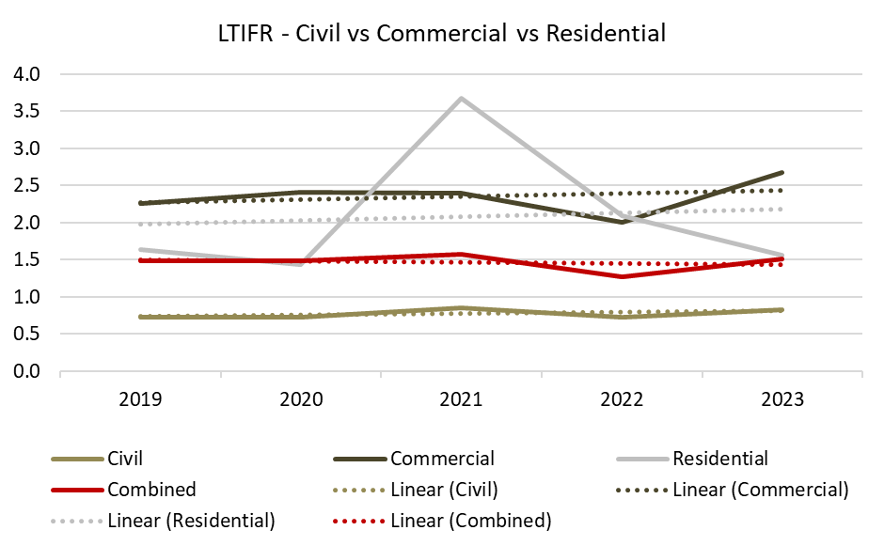

## Medically Treated Injuries

Table 19 and Figure 10 below shows that the medically treated injury frequency rate (MTIFR) for Scheme accredited companies in 2023 was 5.22, an increase of over 9 per cent from the 2022 rate.

The MTIFR for Scheme accredited companies on civil construction was 2.32 in 2023, compared to the MTIFR on commercial construction projects of 9.42. The difference in civil and commercial MTIFR follows the same comparative trend as the difference in civil and commercial LTIFR.

Medically treated injuries reported by Scheme accredited companies have consistently occurred on commercial construction projects at over three times the rate of civil construction projects over the last five years. For 2023, the commercial rate was over *four* times the civil rate. Both the civil and commercial MTIFR reached their lowest rate on record in 2022, then increased in 2023. The civil MTIFR dropped by over 40 per cent from 2019 to 2023, from 3.94 to 2.32, while the commercial MTIFR dropped by 12 per cent from 2019 to 2023, from 10.71 to 9.42. The residential MTIFR saw an increase of over 57 per cent to 13.11 in 2023, from 8.33 in 2019.

#### **Table 19: MTIFR by Construction Type, 2019-23**

|  |  |  |  |  |  |
| --- | --- | --- | --- | --- | --- |
| **MTIFR** | **2019** | **2020** | **2021** | **2022** | **2023** |
| Civil Construction | 3.94 | 2.90 | 2.83 | 2.31 | 2.32 |
| Commercial Construction | 10.71 | 9.19 | 8.63 | 8.06 | 9.42 |
| Residential Construction | 8.33 | 9.51 | 8.87 | 10.12 | 13.11 |
| **Combined** | **7.29** | **5.88** | **5.44** | **4.78** | **5.22** |

#### **Figure 10: MTIFR for Civil, Commercial and Residential construction, 2019-23**

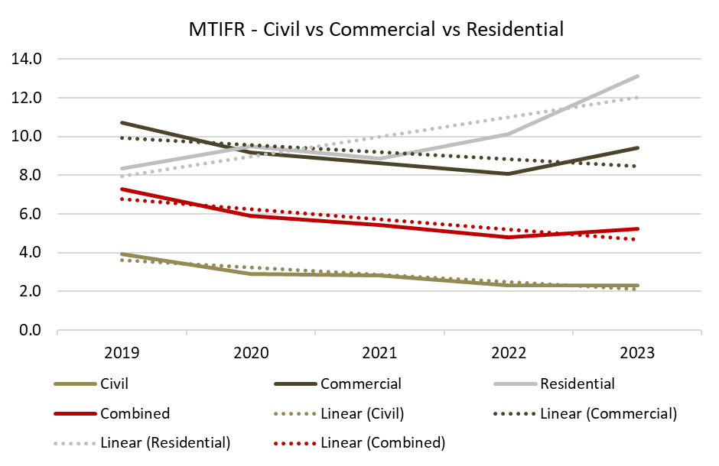

## Fatality Frequency Rates

Table 20 and Figure 11 below shows that the fatality frequency rate (FFR) for Scheme accredited companies in 2023 was 1.41.

#### **Table 20: Fatality Frequency Rates (per 100,000,000 hours worked) by Construction Type, 2019-23**

|  |  |  |  |  |  |
| --- | --- | --- | --- | --- | --- |
| **Year** | **2019** | **2020** | **2021** | **2022** | **2023** |
| **Fatality Frequency Rate (FFR)** | 0.94 | 1.00 | 1.03 | 0.87 | 1.41 |

#### **Figure 11: Fatality Frequency Rates (FFR) for accredited companies, 2019-23**

## Nature of Injuries

Table 21 and Figure 12 below shows the breakdown of injuries from 2023 reported to the OFSC by their nature of injury.

* Wounds, lacerations, amputations and internal organ damage represent just over 40 per cent of the injuries reported in 2023.
* Traumatic joint/ligament and muscle/tendon injuries represent just over a quarter of all injuries reported, while fractures represent approximately 18 per cent of injuries reported.

#### **Table 21: Breakdown of injuries reported to the OFSC by nature of injury, 2023**

|  |  |  |
| --- | --- | --- |
| **Nature of Injury** | **Occurrences** | **Percentage of all injuries reported** |
| **Wounds, lacerations, amputations and internal organ damage** | **460** | 40.5% |
| **Traumatic joint/ ligament and muscle/ tendon injury** | **289** | 25.4% |
| **Fractures** | **207** | 18.2% |
| **Other injuries** | **133** | 11.7% |
| **Burns** | 18 | 1.6% |
| **Other diseases and claims** | 13 | 1.1% |
| **Intracranial injuries** | 9 | 0.8% |
| **Injury to nerves and spinal cord** | 4 | 0.4% |
| **Diseases and conditions** | 3 | 0.3% |

#### **Figure 12: Top 4 nature of injury categories for 2023**

## Mechanism of Injuries

Table 22 and Figure 13 below shows the breakdown of injuries from 2023 reported to the OFSC by their mechanism of injury.

* Just under one-third of injuries on accredited company projects in 2023 involved workers being hit by moving objects.
* Falls, trips and slips, hitting objects with part of the body and body stressing combined make up almost another two-thirds of injuries reported.

#### **Table 22: Breakdown of injuries reported to the OFSC by mechanism of injury, 2023**

|  |  |  |
| --- | --- | --- |
| **Mechanism of Injury** | **Occurrences** | **Percentage of all injuries reported** |
| **Being hit by moving objects** | **349** | 30.7% |
| **Falls, trips and slips of a person** | **314** | 27.6% |
| **Hitting objects with part of the body** | **235** | 20.7% |
| **Body stressing** | **172** | 15.1% |
| **Vehicle incidents and other** | 25 | 2.2% |
| **Heat, electricity and other environmental factors** | 18 | 1.6% |
| **Chemical and other substances** | 17 | 1.5% |
| **Biological factors** | 4 | 0.4% |
| **Others** | 2 | 0.2% |

#### **Figure 13: Top 4 mechanism of injury categories for 2023**

# FSC Annual Census

The OFSC conducts a voluntary, anonymous census on Scheme accredited companies every year. The 2023 Census had 266 responses across a broad range of accredited companies. Table 23 below shows the results for each of the key questions for the last five years.

#### **Table 23: Summary of OFSC Census results for key questions, 2019-23**

|  |  |  |  |  |  |
| --- | --- | --- | --- | --- | --- |
| **Companies stating that…..** | **Percentage by year** | | | | |
| **2019** | **2020** | **2021** | **2022** | **2023** |
| The Scheme has improved safety **practices** in their company | 81 | 80 | 82 | 82 | **69** |
| They have achieved better safety **performance** by becoming accredited | 93 | 93 | 99 | 99 | **96** |
| The OFSC has contributed to improving overall safety in the Building and Construction industry | 96 | 95 | 97 | 98 | **96** |
| Accreditation represents value for money |  |  |  |  |  |
| - Overall | 90 | 87 | 87 | 95 | **94** |
| - Newly accredited companies | 82 | 97 | 100 | 89 | **100** |
| Recommend Scheme accreditation to non-accredited companies | 84 | 87 | 89 | 87 | **83** |
| They are satisfied with the service provided by the OFSC overall | 97 | 96 | 98 | 97 | **97** |
| - OFSC staff are knowledgeable | 97 | 97 | 99 | 95 | **99** |
| - OFSC staff are courteous | 95 | 99 | 99 | 98 | **100** |
| - OFSC staff respond promptly to queries | 95 | 93 | 94 | 93 | **93** |
| - OFSC contact people are accessible | 94 | 95 | 98 | 94 | **96** |
| - OFSC staff clearly communicate responses | 97 | 96 | 98 | 95 | **97** |
| The guidance material provided by the OFSC is readily accessible | 97 | 97 | 98 | 95 | **98** |
| The guidance material provided by the OFSC is clear and easy to understand | 89 | 88 | 89 | 91 | **98** |
| The FSOs that have conducted audits were professional | 99 | 95 | 97 | 96 | **96** |
| The FSOs that have conducted audits were knowledgeable | 98 | 96 | 98 | 95 | **97** |
| They have undertaken a Scheme project | 72 | 68 | 67 | 72 | **69** |
| *Survey response rate* | *64* | *61* | *63* | *52* | ***61*** |
| **Total number of responses** | 230 | 241 | 265 | 216 | **266** |

# Education

A key function of the Federal Safety Commissioner is the promotion of WHS in relation to building work. The OFSC produce a range of educational resources targeting key safety issues in the building and construction industry. The ongoing production of resources include WHS Webinars, Case Studies, Fact Sheets, Checklists and various safety data reports. In 2023, over 1200 live participants attended the OFSC’s online webinars, which have subsequently generated more than 2000 views on the OFSC YouTube channel.

## Webinars

**OFSC WHS Webinar – Mobile Plant Safety, Innovation and Technology, Presentations and Q&A Session**

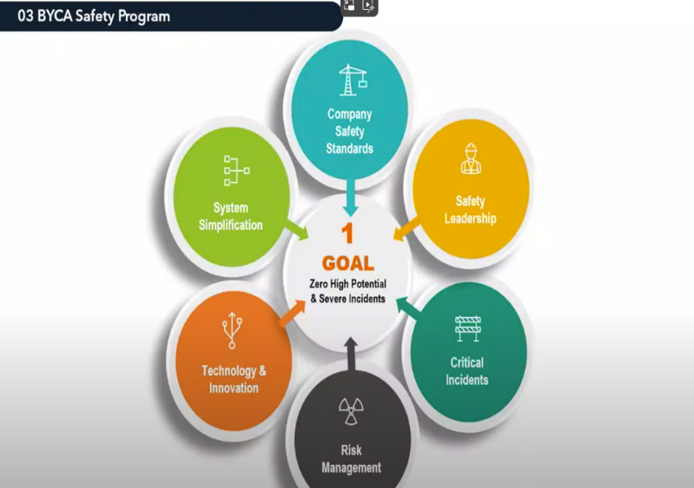The Federal Safety Commissioner’s April 2023 WHS webinar focused on electrical risk management. The webinar covered WHS Accreditation Scheme audit criteria in relation to managing electrical hazards and risks, relevant examples of managing electrical hazards from Scheme accredited builder SHAPE Australia, and a Q&A session with industry experts to close the session. The live session had approximately 400 attendees from companies, regulators, and industry associations.

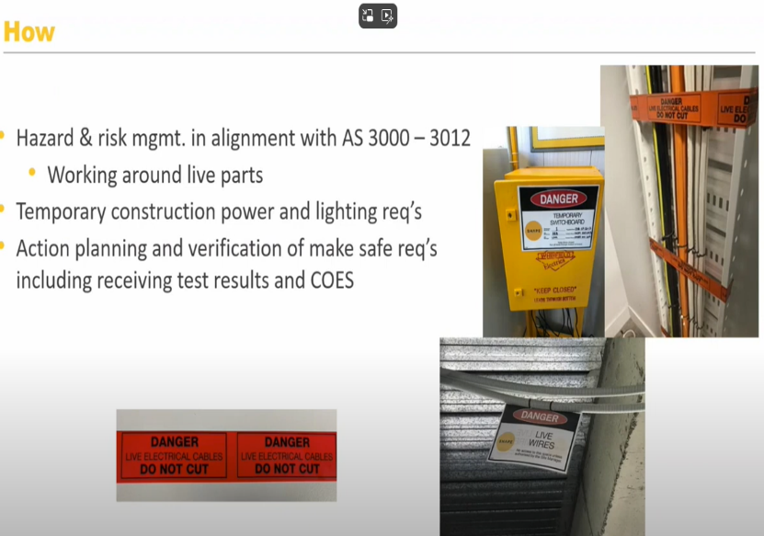**OFSC WHS Webinar – Electrical Risk Management – Presentations and Q&A Session**

The May 2023 webinar featured a comprehensive presentation from Scheme accredited company Bouygues Construction Australia on the company’s mobile plant risk management innovation and technology, and also covered the requirements of meeting WHS Accreditation Scheme audit criteria in relation to mobile plant, closing with a Q&A session. The live session had over 500 attendees from companies, regulators, and industry associations.

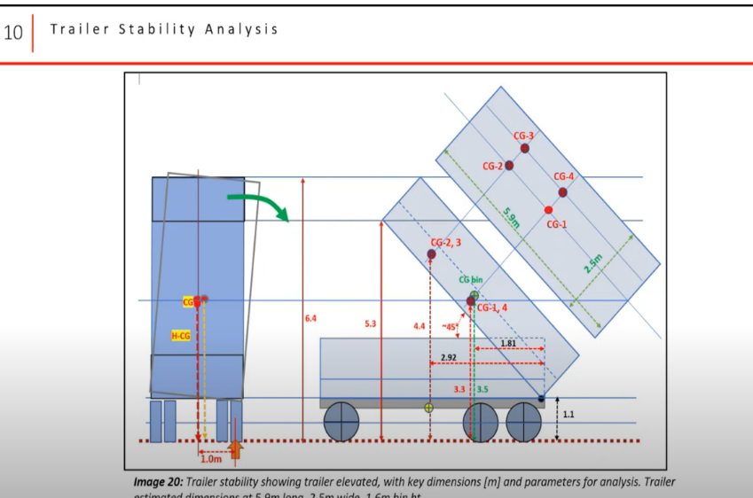**OFSC WHS Webinar –Truck and Trailer Safety, Presentation and Q&A Session**

<https://www.fsc.gov.au/blog/ofsc-whs-webinar-truck-and-trailer-safety-presentation-and-qa-session>

This webinar focused on truck and trailer safety, specifically regarding risk management in relation to tipper trucks. The webinar featured a comprehensive presentation from Scheme accredited company Acciona Australia on the company’s current safety management process for Truck and Trailer Safety. The session closed with a Q&A session.

## Case Studies

This case study video showed the innovative mental health initiative implemented by scheme accredited company Ventia. The Healthy Minds program won the Best Mental Health Program award at the National Safety Council of Australia (NSCA) Foundation and GIO.

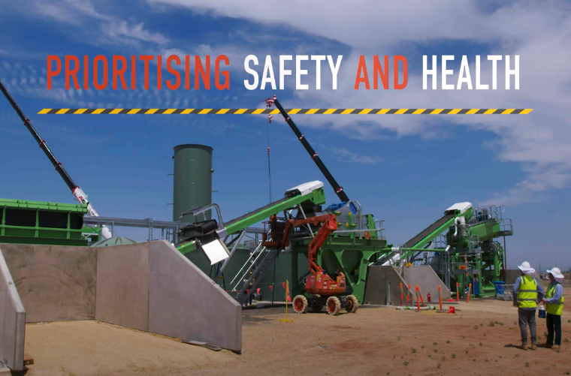**Case Study: Ventia Mental Health Initiative**

<https://www.fsc.gov.au/blog/watch-now-scheme-accredited-builder-ventia-raises-awareness-mental-health-initiative>

This case study video highlights the innovative mental health initiative implemented by Scheme accredited company Ventia. The Healthy Minds program won the Best Mental Health Program award at the NSCA and GIO 2021 National Safety Awards of Excellence.

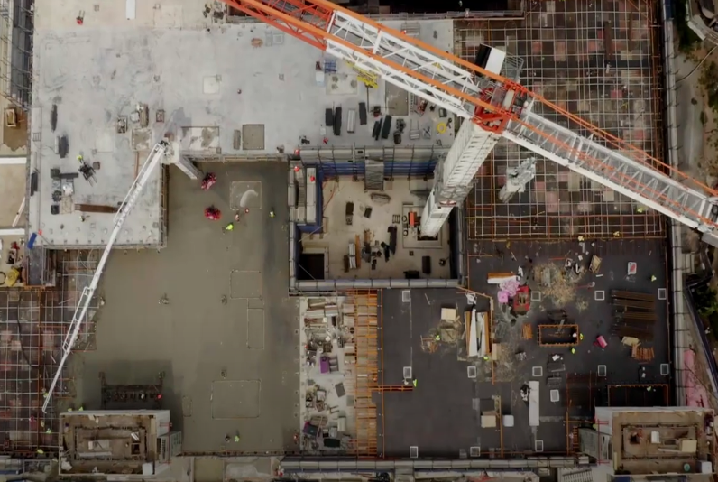**CPB Contractors Case Study – Mobile Elevated Work Platforms**

<https://www.fsc.gov.au/blog/watch-now-case-study-cpb-contractors-mobile-elevated-work-platform-risk-management>

This case study video highlights innovative safety practices of Scheme accredited builder CPB Contractors on secondary safety systems for Mobile Elevated Work Platforms (MEWPs). The video shows the journey CPB Contractors have been on in managing the hazards presented by scissor-type MEWPs on-site since 2014.

## Collaborations

**2023 Safe Work Month collaboration with Ventia** 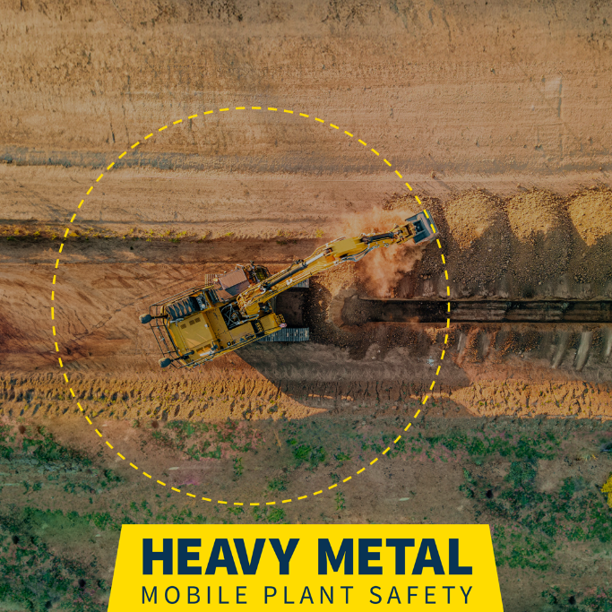

<https://www.fsc.gov.au/blog/know-your-heavy-metal-and-rock>

To mark National Safe Work Month in October 2023 the Office of the Federal Safety Commissioner (OFSC) launched the Heavy Metal Education Campaign, in collaboration with accredited company Ventia. The Campaign provided new educational resources promoting safe work near heavy machinery (mobile plant).

# Glossary

**Accreditation –** The certification by Federal Safety Commissioner of a builder's safety management system as meeting the requirements of the Scheme. This allows the builder to tender for Australian Government projects.

**Accredited company –** A construction company that has been accredited under the Scheme. This company may be accredited in its own right, or part of a joint accreditation.

**Audit –** Accredited Scheme companies are subject to an ongoing audit program, which involve periodic inspections of the Work, Health and Safety processes relevant to the construction they undertake.

**Dangerous occurrence** **–** A work-related occurrence on Scheme Projects where no person is injured, but could have been injured, resulting in serious personal injury, incapacity or death. Also commonly called a “near miss”.

**Fatality** **–** A work-related occurrence on any project where the accredited contractor is the head contractor that results directly or indirectly in the death of a person. Deaths due to natural causes that occur on the project site are reportable to the OFSC but are excluded from this report.

**Lost Time Injury (LTI) –** A work-related occurrence on a Scheme or a Non-Scheme Project where the project value is $4 million or more and the accredited contractor is the head contractor, that results in a permanent disability or time lost from work of one day shift or more.

**Medically Treated Injury (MTI) –** A work-related occurrence that results in the treatment by, or under the order of, a registered medical practitioner, or any injury that could be considered as being one that would normally be treated by a medical practitioner.

**Injury frequency rate** – Injury frequency rates are calculated by the number of incidents over a period divided by hours worked over the same period, multiplied by 1,000,000.

* LTIFR (Lost Time Injury Frequency Rate) - The rate of occurrences of lost time injury that result in a permanent disability or time lost from work of one day shift or more in the period.
* MTIFR (Medically Treated Injury Frequency Rate) - The rate of occurrences of medically treated injuries, which are defined as those of treatment by, or under the order of, a qualified medical practitioner, or any injury that could be considered as being one that would normally be treated by a medical practitioner.
* TRIFR (Total Recorded Injury Frequency Rate) – The total number of Medically Treated Injuries, Lost Time Injuries and Fatalities. Fatalities are excluded from the calculation as they have a negligible effect on the frequency rates.

**Indigenous owned business** – An accredited company that identifies as being at least 50 per cent indigenous owned.

**Joint accreditation –** An accreditation that consists of two or more companies.

**Joint ventures** **–** A project managed by more than one accredited company.

**Mechanism of incident classification**

0. Falls, trips and slips of a person

1. Hitting objects with a part of the body

2. Being hit by moving objects

3. Sound and pressure

4. Body stressing

5. Heat, electricity and other environmental factors

6. Chemicals and other substances

7. Biological factors

8. Mental stress

9. Vehicle incidents and other

**Nature of injury classification**

A. Intracranial injuries

B. Fractures

C. Wounds, lacerations, amputations and internal organ damage

D. Burns

E. Injury to nerves and spinal cord

F. Traumatic joint/ligament and muscle/tendon injury

G. Other injuries

H. Diseases and conditions

**Corrective Action Reports – Major and Minor**

A Corrective Action Report (CAR) is a formal finding made by Federal Safety Officers (FSOs) during the auditing process to identify where companies need to take further action. An FSO raises a CAR when they determine that a certain aspect of the system being audited does not conform to the OFSC audit criteria. This assessment is based on their review of documentary evidence and observation of on-site activities. There are two levels of CARs that can be raised as a result of OFSC audits, major and minor non-conformances:

**A major non-conformance** is where

* a company’s Work Health and Safety Management Systems (WHSMS) contains no documented process or system that meets the OFSC Criteria, or
* the company’s WHSMS fails to meet the Criteria in a substantial way, or
* there is no evidence a company’s WHSMS is being implemented onsite, or
* a company has failed to implement its WHSMS onsite in a substantial way

**A minor non-conformance** is where

* a company’s WHSMS fails to meet the Criteria in a minor way, or
* a company has failed to implement its WHSMS onsite in a minor way.

**Scheme project –** A construction project where an accredited company is the head contractor and has a value of $4m or more and

* is directly funded by the Australian Government, OR
* is indirectly funded by the Australian Government, AND
* the value of the Australian Government contribution to the project is at least $6 million (including GST) and represents at least 50 per cent of the total construction project value OR
* the Australian Government contribution to a project is $10 million (including GST) or more, irrespective of the proportion of Australian Government funding.

**Non-scheme project** **–** A construction project where the accredited company is the head contractor and has a value of $4 million or above but does not otherwise meet the Scheme project criteria above.