**Plant/Person interface is recognised as one of the key fatal risks within construction. Successful and safe management of Tipper Truck activities is based on the provision and maintenance of safe systems of work.**

**KEY RISK FACTORS**

* **Rollover -** Tipper trucks, when tipping, have a high centre of gravity, making them susceptible to rollover accidents, especially when they are fully loaded or operating on uneven terrain. Truck and trailer combinations increase the risk of rollover significantly due to the impact on stability of the trailer when elevated, reversing during tipping, axle alignment, impacts of gradients and uneven ground when articulated.

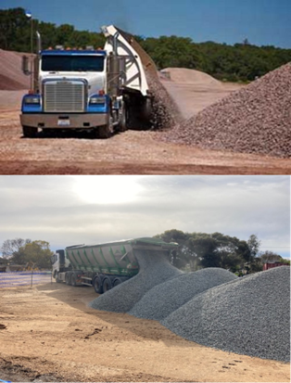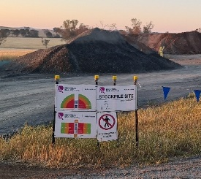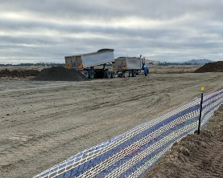

* **Inappropriate trailer selection -** Inappropriate trailers for the site when cross falls and/or grades are present.
* **Overloading -** Overloading a tipper truck can lead to instability, increased braking distance, and greater wear on vehicle components.
* **Poor visibility -** Tipper trucks have blind spots, hindering the driver's visibility. Workers on foot and smaller vehicles may not be visible to the driver.
* **Inadequate training -** Effective training is crucial to ensure drivers understand the specific handling characteristics of tipper trucks, appropriate site preparation and are aware of sites safe systems of work.
* **Distribution of load** - If the load is not distributed across the axles evenly the centre of gravity may be impacted.
* **Mechanical failures -** Brake failures, tyre blowouts, or other malfunctions can lead to accidents if not addressed promptly.
* **Unsafe loading and unloading -** Improper loading/unloading procedures can lead to accidents. Tipping with raised trays must only occur on flat, stable ground, and operators must comply with site safe systems of work.
* **Driver distraction and inattention -** Constantly unloading can become monotonous and could pose a danger if a driver focuses on other things, such as talking on the UHF, scanning smart phone updates, or listening to the radio.
* **The load flow -** Occasionally material does not move out of the top portion of the box or does not flow out of one side of the top portion as expected, e.g. if it is wet. Operators must understand how to identify material movement and how to rectify any issues identified as load sticking in the tray alters the vehicles centre of gravity.
* **The force of high winds -** For longer trailers, the surface area is exposed to high winds. A crosswind pressure on the trailer increases the potential for a tipping incident.

**CONTROLLING THE RISK**

The risks to persons in proximity of a truck or trailer and its fall zone can be catastrophic. To reduce the risks, the following principles should be adopted, commencing from the earliest consideration of the design process applying the hierarchy of controls (HoC).

Eliminate tipping by trucks during site design, e.g. use of conveyors.

Ensure the work site is prepared to the design regarding road surface, slopes, and layout.

**Substitute** tipper trucks for safer alternatives, e.g. bottom unloaders, or rigid trucks only (i.e. not use truck and dog trailers or articulating truck/trailer combinations)

**I**solate people and plant with clearly defined exclusion zones and use of physical barriers to keep people away from tipping operations.

**Provide** engineering controls to identify to operators if there are issues or prevent unsafe situations (e.g. movement with raised tray, CCTV to see if loads are stuck etc)

Provide adequate training and signage to communicate safe systems of work, and enforce exclusion zones and site rules.

**MANAGING THE RISK**

**Safe Systems of Work**

* Ensure any rules about truck/trailer selection and use, access, driving on site, etc are documented and communicated to the supply chain through contracts, the WHS Management Plan, the Project Risk Register, etc.
* Develop a documented Vehicle Movement Plan or Site Traffic Plan identifying the approved tipping areas, any exclusion zones and communicate this to workers using easy to understand language and signage.
* Ensure all loads are evenly distributed within the trailers and in compliance with axle weight limits.
* Ensure the trailer is not moved or rocked whilst the body is elevated as the trailer’s centre of gravity position is raised. Consider Body-up indicators or electronic sensors to alert drivers and/or restrict the truck being driven whilst the trailer is in the raised position.
* Setup the site to eliminate the need for spotters, where practicable. If spotters are required, ensure they are provided a dedicated and safe place to work (e.g. a protected location well outside any dangerous zones), they are trained and there is an effective means of communicating between drivers and spotters.
* Minimise the human interface required with all plant:
  + There is a clear process of spotting and communicating between the driver and a spotter. The spotter can monitor the tipping process from outside the exclusion zone and alert the driver if materials become stuck.
  + Consider engineering controls such as proximity detection systems and visibility aids.
  + Implement exclusion zones and use physical segregating barriers to prevent pedestrians entering the zones. If someone needs to enter into an exclusion zone, ensure that all truck/plant movements cease first, and only recommence after the person on foot has left and provided the necessary all clear.

**Truck Selection and Design**

* Select plant that provides increased levels of stability, for example: conveyors, walking floors, belly dumpers, pusher/ ejector plant, side tippers.
* The hydraulic circuit on the tipper should incorporate load-holding valves that stop uncontrolled lowering of the tipper body in the event of a hydraulic or power failure.
* Control valves and levers should be located to allow access without the need to be under a raised tipper body.
* Body-up alarms let the driver know when the bin is in the raised position via a light and loud alarm in the cab. This reduces the chance of overhead collisions and other safety issues with raised dump bodies.
* Use trailers with non-stick liners to reduce the height the trailer body needs to be elevated and sticking of wet loads.
* Tailgate interlocks prevent raising the trailer body unless the tailgate is unlocked.
* Consider Electronic Stability Control (ESC) system, inbuilt to Tipper Trucks that alert if there is something wrong with the system.

**Work Environment - Site Preparation and Design**

* Ensure the tipping surface area is appropriately prepared before use. This is to ensure the surface area is the correct gradient, compacted, free from any potholes and stable. Ensure supervisory staff know what is required and how unstable ground, potholes etc can increase risks.
* Ensure there is adequate space to align the tipper.
* Use building information modelling (BIM) for the design process to see how plant will operate safely around the site e.g. plant interface between plant and persons, minimisation of reversing movements.
* Undertake regular, ongoing inspections and maintenance of the tipping site to ensure consistency with design.

**Restricted Access Zones/Exclusions Zones**

* Define clear Restricted Access Zones/Exclusions Zones and mandatory processes for entry.
* Ensure formal authorisation by the appropriate authority if entry to zones required.
* Ensure Zones are planned and changed as the project/site changes and changes are effectively communicated to all personnel onsite.

