

Federal Safety Commissioner

Annual Data Report

2022

# Contents

Contents 2

Overview 3

Accreditation Scheme 4

Accreditations 4

Applications 5

Scheme projects 5

Improvements over time 6

Workers’ Compensation Premium Rates over time 7

Scheme Audits 8

Audit Overview 8

Map of Scheme Audit Locations During 2022 8

Audit Breakdown 9

Corrective Action Report Breakdown 9

Audit Head Criteria Issue Rates 10

Audit Sub-criteria Issue Rates 11

Audit Feedback and Assessment 13

Scheme Reporting 14

Fatalities 14

Injury Frequency Rates 14

Lost Time Injuries 15

Medically Treated Injuries 16

Nature of Injuries 17

Mechanism of Injuries 18

FSC Annual Census 19

Education 20

Case Studies 20

Webinars 20

Guidance and Training 22

Glossary 23

# Overview

The Office of the Federal Safety Commissioner (OFSC) acts to improve workplace health and safety (WHS) practices on building and construction sites across Australia. We do this through the administration of the Australian Government Work Health and Safety Accreditation Scheme (the Scheme) and by promoting safety across the industry. There are over 550 accredited companies in Australia performing commercial, civil and residential building and construction projects. Not only are they eligible to be contracted for projects funded by the Australian Government but they are reaping the benefits of improved WHS performance, which include increased productivity, reduced absences, reduced insurance and workers’ compensation costs, improved retention and greater innovation.

Accredited companies are subject to an ongoing, on-site audit program. These on-site audits provide the Government and the community with assurance that the construction work being undertaken by accredited companies is being carried out to the highest of safety standards. Pages 8-13 of this report review some results and trends of the Scheme audit program during 2022.

A condition of accreditation is that accredited companies comply with the reporting requirements of the Scheme. Accredited companies are required to provide information to the OFSC on their WHS performance, including incident reports, hours worked and workers' compensation premium rates. Data and analysis from this information is available throughout this report, with specific incident reporting data found in pages 14-18.

The OFSC conducts a voluntary, anonymous census on Scheme accredited companies every year, with an average of two-thirds of accredited companies responding in recent years. Outcomes of the 2022 Federal Safety Commissioner (FSC) Annual Census are on page 19.

A key function of the Federal Safety Commissioner is the promotion of WHS in relation to building work. On-site audits and reporting on WHS performance enables the OFSC to assess the impact of the Scheme on industry safety, the ongoing suitability of companies to remain accredited under the Scheme, and to determine WHS trends and benchmarks. This in turn allows the OFSC to provide relevant, useful best practice advice to aid in the improvement of WHS awareness and culture in the building and construction industry. The OFSC produce a range of educational resources targeting these identified key safety issues. The ongoing production of resources include WHS Webinars, Case Studies, Fact Sheets, Checklists and various safety data reports, shown on pages 20-22.

# Accreditation Scheme

## Accreditations

An accreditation represents one or more companies operating with the same Scheme accredited WHS Management System. At the end of 2022, 427 Scheme accreditations represented 561 companies. Accredited companies continue to be a significant part of the Australian building and construction industry, with around $83 billion in Scheme projects active throughout 2022, part of a total of $197 billion in Scheme projects since the Scheme started (see page 5).

* There are 38 Indigenous owned accredited companies. This more than doubles the number of accredited Indigenous companies at the end of 2019.
* Small to medium construction companies, and regional construction companies, are an important part of the Scheme. Two thirds of Scheme accredited companies are classified as small or medium in size, and 11% of Scheme accredited companies operate in regional locations only, showing that the size or location of a company is no barrier to entry for achieving best practice safety.

In 2022 the Federal Safety Commissioner approved 28 new accreditations. There has been an annual average of 32 new accreditations over the past 5 years. At the end of 2022 there were 427 active Scheme accreditations.

The number of active Scheme accreditations at the end of each year subtracts those accreditations which have expired, been withdrawn, or suspended. Joint accreditations account for 19% of all accreditations.

|  |  |  |  |  |  |
| --- | --- | --- | --- | --- | --- |
|  | **2018** | **2019** | **2020** | **2021** | **2022** |
| **Accreditations** | 374 | 383 | 409 | 426 | 427 |

## Applications

The OFSC received 68 new applications for accreditation in 2022. Over the past 5 years an annual average of 77 new applications were received. There were 92 reaccreditation applications submitted in 2022. Over the past 5 years there has been an annual average of 70 reaccreditation applications.

|  |  |  |  |  |  |  |
| --- | --- | --- | --- | --- | --- | --- |
|  | **2018** | **2019** | **2020** | **2021** | **2022** | **5 year average** |
| **New Accreditation Applications** | 76 | 67 | 89 | 83 | 68 | 77 |
| **Re-accreditation Applications** | 51 | 45 | 72 | 89 | 92 | 70 |

## Scheme projects

Building commenced on 227 new Scheme projects in 2022. These new projects make up 39% of the 586 projects that were active during 2022. The 586 scheme projects active during 2022 had a combined value of $83.4 billion.

|  |  |  |  |  |  |  |
| --- | --- | --- | --- | --- | --- | --- |
|  | **2018** | **2019** | **2020** | **2021** | **2022** | **5 year average** |
| **Total Active Scheme Projects** | 426 | 456 | 471 | 532 | 586 | 494 |

At the end of 2022, accredited companies had been head contractor on 2,689 projects since the Scheme began in 2006. These projects have had a combined value of $197 billion.

|  |  |  |  |  |  |
| --- | --- | --- | --- | --- | --- |
|  | **2018** | **2019** | **2020** | **2021** | **2022** |
| **Total Scheme Projects** | 1,882 | 2,047 | 2,221 | 2,462 | 2,689 |
| **Value (Billions)** | $119.8 | $133.5 | $148.7 | $165.7 | $197 |

## Improvements over time

An analysis of lost time injury frequency rates (LTIFR) of Scheme accredited companies measured at three-year intervals in comparison to their LTIFR when first accredited shows that after three years of accreditation, 52% of companies reduced their LTIFR by an average of 77%.  After six years this increased to 63% of companies having reduced their LTIFR by an average of 88%. After 12 years, 77% of companies had reduced their LTIFR by an average of 88%.

|  |  |  |  |  |
| --- | --- | --- | --- | --- |
|  | **Years Accredited under the Scheme** | | | |
|  | **3 years** | **6 years** | **9 years** | **12 years** |
| **Accredited Companies with Improved LTIFR** | 52% | 63% | 75% | 77% |
| **Average Improvement to LTIFR** | 77% | 88% | 91% | 88% |

## Workers’ Compensation Premium Rates over time

Scheme accredited companies have reported to the OFSC lower workers’ compensation premium rates (WCPR) over time.

* After 3 years of accreditation, 59% of companies reduced their WCPR by an average of 35%.
* After 6 years this has increased to 61% of companies having reduced their WCPR by an average of 38%.
* This WCPR reduction increases again after 12 years, with 72% of companies reducing their WCPR by an average of 49%.

|  |  |  |  |  |
| --- | --- | --- | --- | --- |
|  | **Years Accredited under the Scheme** | | | |
|  | **3 years** | **6 years** | **9 years** | **12 years** |
| **Accredited Companies with Improved WCPR** | 59% | 61% | 71% | 72% |
| **Average Improvement to WCPR** | 35% | 38% | 45% | 49% |

# Scheme Audits

## Audit Overview

Scheme accredited companies undergo regular on-site safety audits as a requirement of accreditation. These audits are conducted by Federal Safety Officers (FSOs) against the FSC Audit Criteria. Company audit performance informs the OFSC risk management approach, which guides the frequency and focus of future audits and potential compliance action.

## Map of Scheme Audit Locations During 2022

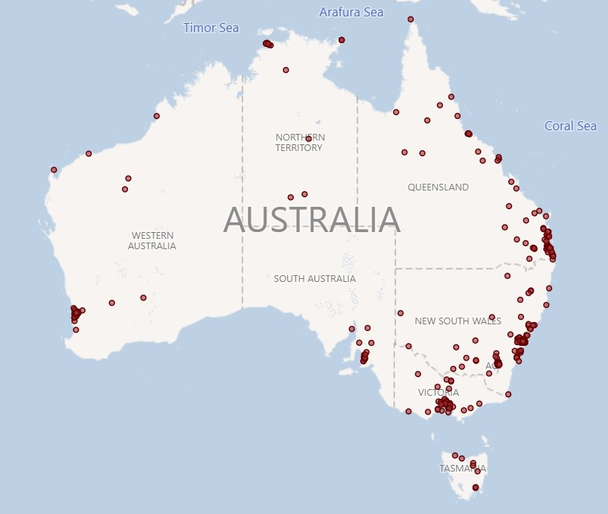

The OFSC conducted 526 safety audits in 2022 across 750 days on-site. During these audits:

* 2,930 Corrective Action Reports (CARs) were issued,
* 25.6% were Major CARs (750), and
* 74.4% were Minor CARs (2,180) [an explanation of Major and Minor CARs is in the glossary on page 23].

|  |  |  |  |  |  |
| --- | --- | --- | --- | --- | --- |
|  | **2018** | **2019** | **2020** | **2021** | **2022** |
| **Audits** | 438 | 428 | 404 | 452 | 526 |
| **Audit days on-site** | 622 | 572.5 | 560.5 | 624.5 | 750 |

## Audit Breakdown

On-site audits assess the WHS Management System (WHSMS) implementation of companies applying for Scheme accreditation. Once accredited, it is a requirement of maintaining accreditation to undergo regular on-site audits. In 2021 the OFSC introduced System Validations Audits (SVAs), which are a desktop audit process conducted prior to the initial on-site audit to assist applicants in identifying areas of their WHSMS that do not currently meet Scheme standards. This allows applicants to be more before their first on-site audit as they aim to achieve accreditation. This has decreased the number of on-site audits being conducted on applicants and created capacity for more on-site audits of accredited companies.

|  |  |  |  |  |  |
| --- | --- | --- | --- | --- | --- |
|  | **2018** | **2019** | **2020** | **2021** | **2022** |
| **Accredited Company audits** | 346 | 327 | 273 | 325 | 387 |
| **Non-accredited Company audits** | 92 | 101 | 131 | 99 | 52 |
| **System Validation Audits** | 0 | 0 | 0 | 28 | 87 |

## Corrective Action Report Breakdown

Following a consistent total of CARs issued from 2018 to 2021, the total number of CARs in 2022 dropped below 3,000. This is due to the impact of the SVAs that assist companies in implementing more robust WHSMS prior to their initial on-site audit. Companies are informed about areas of their WHSMS that do not meet Scheme requirements, but CARs are not issued. The number of CARs issued to accredited companies has increased by 17 and 18 per cent for major and minor respectively. Due to SVAs, non-accredited company’s CARs have dropped by 87 and 48 per cent for major and minor respectively from 2021 to 2022.

|  |  |  |  |  |  |
| --- | --- | --- | --- | --- | --- |
|  | **2018** | **2019** | **2020** | **2021** | **2022** |
| **Accredited Major** | 680 | 508 | 620 | 534 | 623 |
| **Accredited Minor** | 1275 | 1352 | 1130 | 1577 | 1858 |
| **Non-accredited Major** | 1281 | 1521 | 1196 | 969 | **127** |
| **Non-accredited Minor** | 639 | 731 | 849 | 622 | **322** |
| **Totals** | **3875** | **4112** | **3795** | **3702** | **2930** |

## Audit Head Criteria Issue Rates

The highest CAR issue rates for audit head criteria across audits on both accredited companies and applicants applying for accreditation related to Health Surveillance and Exposure Monitoring, Senior Management Commitment, meeting Legal Requirements and Emergency Preparedness and Response.

|  |  |  |  |  |
| --- | --- | --- | --- | --- |
| **Highest Issued CARs by Audit Head Criteria on all Audits** | | **CARs Issued** | **% of all CARs issued** | **Issue rate** |
| **WH14** | **Health Surveillance and Exposure Monitoring** | 161 | 5.5% | 41.3% |
| **FP1** | **Senior Management Commitment** | 188 | 6.4% | 39.7% |
| **WH3** | **Legal Requirement** | 84 | 2.9% | 33.7% |
| **WH13** | **Emergency Preparedness and Response** | 237 | 8.1% | 33.6% |
| **WH17** | **Health & Safety Management System Audit** | 76 | 2.6% | 32.8% |
| **WH15** | **Incident Investigation and Corrective Action** | 113 | 3.9% | 30.6% |
| **FP3** | **Whole of Project Consultation** | 58 | 2.0% | 29.8% |
| **FP5** | **Project Performance Measurement** | 63 | 2.2% | 26.4% |
| **H5** | **Structural Alterations/Temporary Support Structures** | 170 | 5.8% | 24.7% |
| **H14** | **Tilt up/Precast Concrete** | 19 | 0.6% | 24.7% |

## Audit Sub-criteria Issue Rates

The sub-criteria issue rates in this report are broken down into builders who are not accredited but have undergone on-site audits in the process of applying for accreditation, and Scheme accredited builders. Sub-criteria reviewed less than 20 times have been excluded.

* **WH14.1**, which requires a documented process to ensure a competent person completes an assessment of health hazards is the highest issue rate for non-accredited builders with a very high 60%.
* **FP1.3**, which requires a documented process to ensure senior managers, site managers and supervisors are trained in WHS obligations, due diligence and the company's WHS management system requirements relevant to their role is the highest issue rate CAR for Scheme accredited builders.

| **Top Ten Highest Issue Rate CARs by Audit Sub Criteria for**  **Non-accredited companies applying for Scheme accreditation** | **Issue Rate** | **Times issued** | **Times reviewed** |
| --- | --- | --- | --- |
| WH14.1 There is a documented process to ensure a competent person completes a site-specific assessment of potential health hazards, including biological; physical; and chemical/atmospheric contaminants. | 60.0% | 15 | 25 |
| WH14.3 There is a documented process to ensure that worker health surveillance/monitoring is carried out in accordance with identified health hazards;is carried out in accordance with relevant legislation, codes of practice and Australian standards; and includes a process for management and communication of health monitoring results and records. | 52.0% | 13 | 25 |
| WH13.8 There is a documented process to ensure inspection, test and maintenance requirements for emergency and first aid equipment are identified, scheduled and undertaken. | 48.0% | 12 | 25 |
| H16.3 Safe systems of work are established for the operation of mobile plant taking into account: the operator manual; outcomes from the plant risk assessment; site specific requirements; and the need for ROPS and FOPS. | 45.0% | 9 | 20 |
| H16.5 Safe systems of work have been developed for the use of mobile cranes taking into account: ground conditions; development of lift plans in accordance with relevant legislation, codes of practice and Australian standards; and lifting of materials and workers. | 45.0% | 9 | 20 |
| H16.10 The system ensures that there is a process for the ongoing maintenance of mobile plant. | 45.0% | 9 | 20 |
| FP1.2 There is a documented process to ensure WHS reports are produced that monitor performance against the WHS objectives and targets defined by the organisation; are regularly reviewed by senior management; and are communicated to site management. | 44.0% | 11 | 25 |
| FP1.4 There is a documented process that ensures senior managers regularly visit the site and discuss WHS issues with site management and workers. | 44.0% | 11 | 25 |
| WH13.4 There is a documented process to ensure designated emergency personnel for the project have been inducted in the site-specific emergency procedures/plans; and have obtained any qualification or formal training defined by the company as required to fulfill the role. | 44.0% | 11 | 25 |
| WH13.5 There is a documented process to ensure emergency practice drills are scheduled and carried out on site; are scenario based and test a variety of the identified potential emergency situations; are recorded and evaluated for effectiveness; and incorporate a process for the identification and management of corrective actions. | 40.0% | 10 | 25 |

| **Top Ten Highest Issue Rate CARs by Audit Sub Criteria for**  **Scheme accredited builders** | **Issue Rate** | **Times issued** | **Times reviewed** |
| --- | --- | --- | --- |
| FP1.3 There is a documented process to ensure senior managers, site managers and supervisors are trained in WHS obligations/due diligence, and the company’s WHS management system requirements relevant to their role. | 55.7% | 54 | 97 |
| H7.6 The system ensures that the excavation is regularly inspected by a competent person to monitor the effectiveness of controls in accordance with the drawing/plan/permit. | 54.9% | 45 | 82 |
| FP3.1 There is a documented process for the establishment of WHS consultation, cooperation and coordination arrangements, including agreement on the establishment of consultation arrangements with workers on site; consultation with workers or their representatives when WHS issues arise; a program to ensure regular meetings with minutes of the meetings available to all workers; and training for health and safety representatives and WHS committee members where requested or required. | 53.7% | 22 | 41 |
| WH13.7 There is a documented process to ensure a competent person identifies site emergency equipment and requirements. | 48.9% | 23 | 47 |
| WH13.5 There is a documented process to ensure emergency practice drills are scheduled and carried out on site; are scenario based and test a variety of the identified potential emergency situations; are recorded and evaluated for effectiveness; and incorporate a process for the identification and management of corrective actions. | 48.5% | 32 | 66 |
| WH14.1 There is a documented process to ensure a competent person completes a site-specific assessment of potential health hazards, including biological; physical; and chemical/atmospheric contaminants. | 47.1% | 32 | 68 |
| WH13.4 There is a documented process to ensure designated emergency personnel for the project have been inducted in the site-specific emergency procedures/plans; and have obtained any qualification or formal training defined by the company as required to fulfill the role. | 46.8% | 22 | 47 |
| H1.4 Safe systems of work have been developed to ensure that where fall restraint/fall arrest equipment is being used on site workers have been formally trained in the use of such equipment; there is a maintenance and inspection schedule for the equipment; attachment points are designed and certified by a qualified person; and attachment points are installed by a trained person and regularly inspected by a competent person. | 46.6% | 54 | 116 |
| H7.5 The system ensures that where shoring systems or other documented methods are utilised, they are designed by a qualified engineer; detailed on up-to-date drawings/plans; installed by competent persons and verified as correctly installed prior to use in accordance with the drawing/plan; and authorised and signed off by a qualified engineer where changes to the design or installed system are made | 46.3% | 38 | 82 |
| FP1.2 There is a documented process to ensure WHS reports are produced that monitor performance against the WHS objectives and targets defined by the organisation; are regularly reviewed by senior management; and are communicated to site management. | 46.3% | 44 | 95 |

|  |  |  |  |  |  |
| --- | --- | --- | --- | --- | --- |
| **2022 Scheme accredited top 5 Sub-criteria over past five years** | **2018** | **2019** | **2020** | **2021** | **2022** |
| FP1.3 There is a documented process to ensure senior managers, site managers and supervisors are trained in WHS obligations/due diligence, and the company’s WHS management system requirements relevant to their role. | 43.8% | 42.4% | 41.9% | 49.3% | 55.7% |
| H7.6 The system ensures that the excavation is regularly inspected by a competent person to monitor the effectiveness of controls in accordance with the drawing/plan/permit. | 42.6% | 42.3% | 48.3% | 41.1% | 54.9% |
| FP3.1 There is a documented process for the establishment of WHS consultation, cooperation and coordination arrangements, including agreement on the establishment of consultation arrangements with workers on site; consultation with workers or their representatives when WHS issues arise; a program to ensure regular meetings with minutes of the meetings available to all workers; and training for health and safety representatives and WHS committee members where requested or required. | 16.1% | 54.5% | 50.0% | 43.8% | 53.7% |
| WH13.7 There is a documented process to ensure a competent person identifies site emergency equipment and requirements. | 41.8% | 46.4% | 25.4% | 35.4% | 48.9% |
| WH13.5 There is a documented process to ensure emergency practice drills are scheduled and carried out on site; are scenario based and test a variety of the identified potential emergency situations; are recorded and evaluated for effectiveness; and incorporate a process for the identification and management of corrective actions. | 38.5% | 39.3% | 36.2% | 53.0% | 48.5% |

The sub criteria with the five highest issue rates in 2022 have all trended up from 2018 to 2022.

## Audit Feedback and Assessment

The OFSC’s annual census of accredited companies in 2022 identified that 96% of respondents agreed FSOs had been professional, 95% agreed that they were knowledgeable and 89% agreed that FSOs were collaborative. At the conclusion of each audit companies are provided with an evaluation form seeking feedback on FSO performance. The response rate for this form reached its highest level in 2022 at 42%. The majority of companies agree the OFSC and FSOs are performing their roles appropriately, with an average performance score of 4.5 out of 5.

# Scheme Reporting

Scheme accredited builders are required to submit incident reports for all incidents that occur on building projects where they are the head contractor. This applies to incidents occurring to all workers on-site, directly employed and all subcontractors.

## Fatalities

In 2022, four fatal incidents were reported on Scheme accredited building sites. Scheme accredited companies represent around 28% of annual construction industry turnover, yet accounted for an average of 16% of workplace fatalities from 2018-2022. In 2022, of the four fatalities occurring on Scheme accredited sites, three related to mobile plant and one to temporary support structures.

|  |  |  |  |  |  |
| --- | --- | --- | --- | --- | --- |
|  | **2018** | **2019** | **2020** | **2021** | **2022** |
| **Scheme Fatalities** | 5 | 4 | 4 | 4 | 4 |
| **Total Industry Fatalities\*** | 24 | 28 | 36 | 24 | 17 |

**\*Industry fatality data is taken from Safe Work Australia’s (SWA) Work-Related Traumatic Injury Fatalities Report over multiple years. The report is available on the SWA website.**

## Injury Frequency Rates

The total recorded injury frequency rate (TRIFR) for Scheme accredited companies is calculated by combining LTIFR and MTIFR. From 2018-2022 the TRIFR has decreased substantially from 8.39 to 5.84. This was driven by the decrease in MTIFR, dropping from 6.66 in 2018 to 4.62 in 2022, and the decrease in LTIFR from 1.73 in 2018 and 1.23 in 2022.

|  |  |  |  |  |  |
| --- | --- | --- | --- | --- | --- |
|  | **2018** | **2019** | **2020** | **2021** | **2022** |
| **LTIFR** | 1.73 | 1.45 | 1.49 | 1.51 | 1.23 |
| **MTIFR** | 6.66 | 7.19 | 5.74 | 5.37 | 4.62 |
| **TRIFR** | 8.39 | 8.64 | 7.23 | 6.89 | 5.84 |

## Lost Time Injuries

The lost time injury frequency rate (LTIFR) for Scheme accredited companies reached its lowest rate ever in 2022 at 1.23, down from 1.50 in 2021 and from 1.73 in 2018. The LTIFR on civil construction projects conducted by Scheme accredited companies in 2022 was 0.73. This is substantially lower than the LTIFR on commercial construction projects conducted by Scheme accredited companies, which was 1.98.

Over the past 5 years, lost time injuries reported by Scheme accredited companies have consistently occurred on commercial construction projects at approximately three times the rate of civil construction projects. This is not unexpected given there is more high risk activity occurring at a highest density of workers more frequently. From 2018 to 2022, the LTIFR decreased on commercial projects by 26%, compared to a 23% decrease in LTIFR for civil projects.

|  |  |  |  |  |  |
| --- | --- | --- | --- | --- | --- |
| **LTIFR** | **2018** | **2019** | **2020** | **2021** | **2022** |
| **Civil Construction LTIFR** | 0.95 | 0.73 | 0.73 | 0.82 | 0.73 |
| **Commercial Construction LTIFR** | 2.69 | 2.21 | 2.41 | 2.39 | 1.98 |
| **Combined LTIFR** | 1.73 | 1.45 | 1.48 | 1.50 | 1.23 |

## Medically Treated Injuries

The medically treated injury frequency rate (MTIFR) for Scheme accredited companies in 2022 was 4.62, reaching its lowest point ever, following the continuous downward trend of the last five years.

The MTIFR for Scheme accredited companies on civil construction was 2.31 in 2021, compared to the MTIFR on commercial construction projects of 8.06. The difference in civil and commercial MTIFR follows the same comparative trend as the difference in civil and commercial LTIFR.

Medically treated injuries reported by Scheme accredited companies have consistently occurred on commercial construction projects at over three times the rate of civil construction projects over the last five years. Both the civil and commercial MTIFR reached their lowest rate on record in 2022, continuing their downwards trend. The civil MTIFR dropped by over one point from 2018 to 2022, from 3.53 to 2.31. The commercial MTIFR dropped by more than 2 points from 2018 to 2022, from 10.53 to 8.06.

|  |  |  |  |  |  |
| --- | --- | --- | --- | --- | --- |
| **MTIFR** | **2018** | **2019** | **2020** | **2021** | **2022** |
| **Civil Construction MTIFR** | 3.53 | 3.94 | 2.90 | 2.82 | 2.31 |
| **Commercial Construction MTIFR** | 10.53 | 10.61 | 9.21 | 8.69 | 8.06 |
| **Combined MTIFR** | 6.66 | 7.19 | 5.74 | 5.37 | 4.62 |

## Nature of Injuries

* Wounds, lacerations, amputations and internal organ damage represent just under half of the injuries reported in 2022.
* Traumatic joint/ ligament and muscle/ tendon injury, and fractures both represent approximately 20% each of injuries reported.

|  |  |  |
| --- | --- | --- |
| **Nature of Injury** | **Occurrences** | **%** |
| **Wounds, lacerations, amputations and internal organ damage** | **342** | 43.6% |
| **Traumatic joint/ ligament and muscle/ tendon injury** | **170** | 21.7% |
| **Fractures** | **152** | 19.4% |
| **Other injuries** | **95** | 12.1% |
| **Burns** | 11 | 1.4% |
| **Intracranial injuries** | 6 | 0.8% |
| **Injury to nerves and spinal cord** | 5 | 0.6% |
| **Diseases and conditions** | 2 | 0.3% |
| **Other diseases and claims** | 1 | 0.1% |

## Mechanism of Injuries

* One-third of injuries on accredited company projects in 2022 involved workers being hit by moving objects.
* Falls, trips and slips, hitting objects with part of the body and body stressing make up the majority of other injuries reported.

|  |  |  |
| --- | --- | --- |
| **Mechanism of Injury** | **Occurrences** | **%** |
| **Being hit by moving objects** | **262** | 33.4% |
| **Falls, trips and slips of a person** | **196** | 25.0% |
| **Hitting objects with part of the body** | **195** | 24.9% |
| **Body stressing** | **90** | 11.5% |
| **Heat, electricity and other environmental factors** | 16 | 2.0% |
| **Vehicle incidents and other** | 15 | 1.9% |
| **Chemical and other substances** | 7 | 0.9% |
| **Biological factors** | 3 | 0.4% |

# FSC Annual Census

The OFSC conducts a voluntary, anonymous census on Scheme accredited companies every year. The 2022 Census had 216 responses across a broad range of accredited companies.

|  |  |  |  |  |
| --- | --- | --- | --- | --- |
| **Percentage of companies stating that…..** | **2019** | **2020** | **2021** | **2022** |
| The Scheme has improved safety **practices** in their company | 81% | 80% | 82% | **82%** |
| They have achieved better safety **performance** by becoming accredited | 93% | 93% | 99% | **99%** |
| The OFSC has contributed to improving overall safety in the Building and Construction industry | 96% | 95% | 97% | **98%** |
| Accreditation represents value for money |  |  |  |  |
| - Overall | 90% | 87% | 87% | **95%** |
| - Newly accredited companies | 82% | 97% | 100% | **89%** |
| Recommend Scheme accreditation to non-accredited companies | 84% | 87% | 89% | **87%** |
| They are satisfied with the service provided by the OFSC overall | 97% | 96% | 98% | **97%** |
| - OFSC staff are knowledgeable | 97% | 97% | 99% | **95%** |
| - OFSC staff are courteous | 95% | 99% | 99% | **98%** |
| - OFSC staff respond promptly to queries | 95% | 93% | 94% | **93%** |
| - OFSC contact people are accessible | 94% | 95% | 98% | **94%** |
| - OFSC staff clearly communicate responses | 97% | 96% | 98% | **95%** |
| The guidance material provided by the OFSC is readily accessible | 97% | 97% | 98% | **95%** |
| The guidance material provided by the OFSC is clear and easy to understand | 89% | 88% | 89% | **91%** |
| The FSOs that have conducted audits were professional | 99% | 95% | 97% | **96%** |
| The FSOs that have conducted audits were knowledgeable | 98% | 96% | 98% | **95%** |
| They have undertaken a Scheme project | 72% | 68% | 67% | **72%** |
| Survey response rate | 64% | 61% | 63% | **52%** |
| **Total number of responses** | 230 | 241 | 265 | **216** |

# Education

A key function of the Federal Safety Commissioner is the promotion of WHS in relation to building work. The OFSC produce a range of educational resources targeting key safety issues in the building and construction industry. The ongoing production of resources include WHS Webinars, Case Studies, Fact Sheets, Checklists and various safety data reports.

## Case Studies

**WestConnex M4-M5 Link Tunnels’ technical innovation in hazard reduction and safety management**

This case study video highlights the WestConnex M4-M5 Link Tunnels’ range of innovative and technologically advanced practices and solutions integrated throughout the three major work sites.

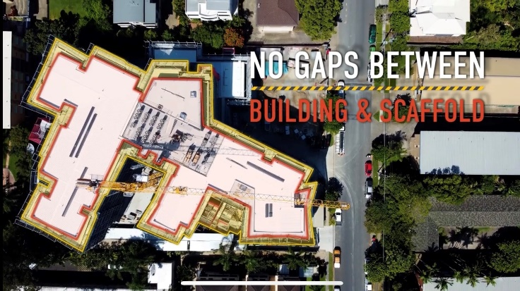 **Scheme Accredited builder Paynters prioritises Scaffold safety**

This case study video shows the innovative safety practices of Scheme accredited builder Paynters on their upgrade of the Berlasco Court Caring Centre in Indooroopilly, Queensland. Scaffolding safety is at the forefront of this project for Paynters as they aim to eliminate major safety risks on their 22-metre high scaffolding.

## Webinars

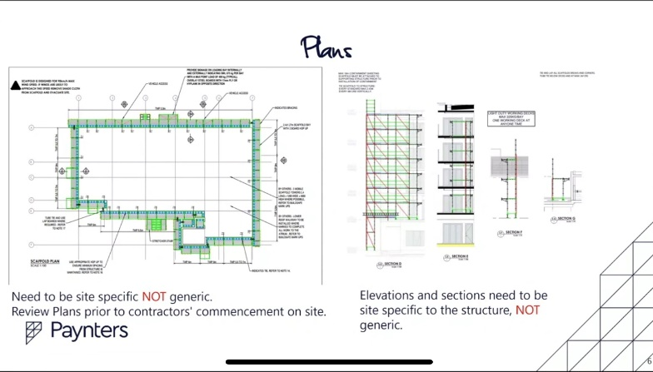**Online WHS Webinar – Scaffolding Risk Management**

This webinar was part of the OFSC’s response to its 2020-2021 safety campaign which identified low levels of compliance with scaffolding safety requirements. Featuring a presentation by accredited company Paynters, Federal Safety Commissioner David Denney hosted the webinar, with approximately 600 attendees from companies, regulators, and industry associations.

**OFSC WHS Webinar – Traffic Management**

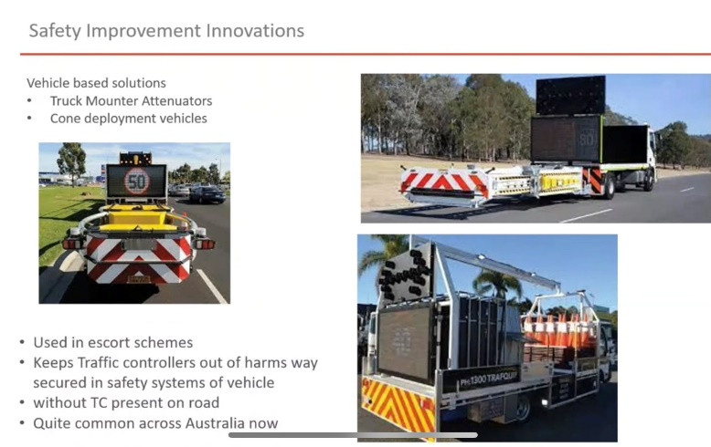This July 2022 webinar focused on temporary traffic management. The webinar aimed to increase education and awareness around the current requirements for temporary traffic management, both under the Scheme and in state and territory jurisdictions. Federal Safety Commissioner David Denney hosted the webinar, with approximately 500 attendees from companies, regulators, and industry associations.

**OFSC WHS Webinar – Mental health in the building and construction industry**

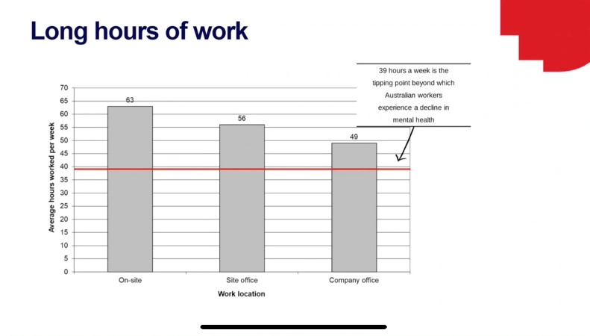 This webinar aimed to expand understanding of what can cause mental health hazards in the building industry, the relevant regulations and codes of practice, and examples of practical mental health risk management. OFSC’s Chris Marlton hosted the webinar, with approximately 400 attendees from companies, regulators, and industry associations.

**OFSC WHS Webinar – Excavation Risk Management**

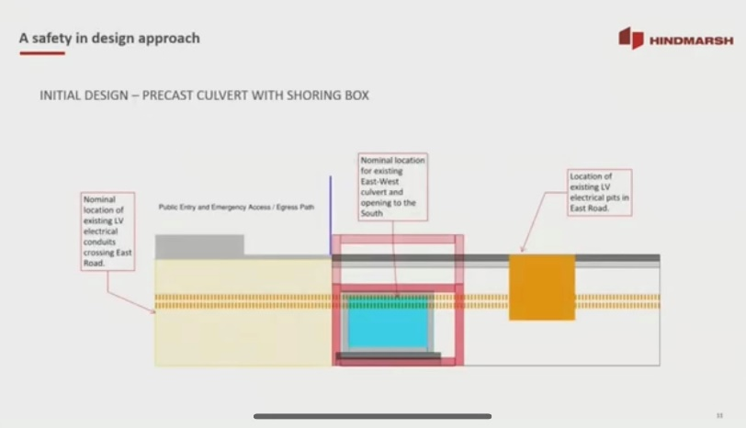Our November 2022 webinar focused on excavation risk management. The webinar covered WHS Accreditation Scheme audit criteria in relation to managing excavations, relevant examples of managing complicated excavations in a current project from Scheme accredited builder Hindmarsh Constructions, and a Q&A session with industry experts to close the session. Federal Safety Commissioner David Denney hosted the webinar, with approximately 350 attendees from companies, regulators, and industry associations.

## Guidance and Training

**Managing risks to mental health**

A new mental health webpage to assist building companies to connect with mental health and wellbeing resources. The new webpage aims to make it easier for building companies to understand their safety obligations in relation to mental health and to connect with support programs including Commonwealth and State/Territory Government Guidelines and codes of practice, resources and toolkits, and other industry initiatives. Exposure to psychosocial hazards, and the risk of psychological injury as a result, is a serious problem affecting the building and construction industry.

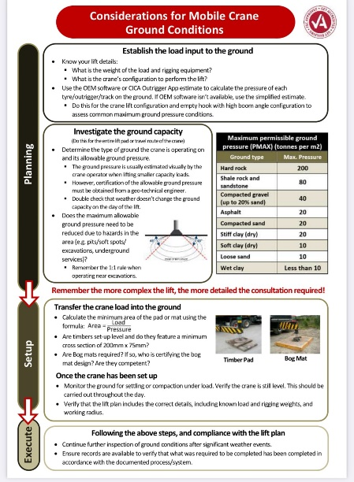

**Mobile crane ground conditions guidance**

Developed in consultation with FSOs and the Crane Industry Council of Australia, this new guidance workflows the process of verifying the capacity of the ground to safely carry the weight of the crane under load. This is key to ensuring the stability of the crane and preventing rollovers. Companies accredited under the WHS Accreditation Scheme need to have, and implement on-site, a systems-based approach to ensure compliance with mobile crane requirements.

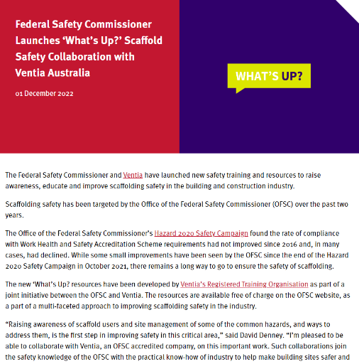**‘What’s Up?’ Scaffold Safety Collaboration with Ventia**

The Federal Safety Commissioner and Ventia launched safety training and resources to raise awareness, educate and improve scaffolding safety in the building and construction industry. Scaffolding safety has been targeted by the OFSC over the past two years. The resources are available free of charge on the OFSC website as a part of a multi-faceted approach to improving scaffolding safety in the industry.

# Glossary

**Dangerous occurrence** - An incident where no person is injured, but could have been injured, resulting in serious personal injury, incapacity or death. Also commonly called a “near miss”.

**Frequency rate** - Frequency rates are calculated by the number of incidents divided by hours worked, multiplied by 1,000,000.

* LTIFR (Lost Time Injury Frequency Rate) - The number of occurrences of lost time injury that result in a permanent disability or time lost from work of one day shift or more in the period.
* MTIFR (Medically Treated Injury Frequency Rate) - The number of occurrences of treatment by, or under the order of, a qualified medical practitioner, or any injury that could be considered as being one that would normally be treated by a medical practitioner.
* TRIFR (Total Recorded Injury Frequency Rate) – The total number of Medically Treated Injuries, Lost Time Injuries and Fatalities. Fatalities are excluded from the calculation as they have a negligible effect on the frequency rates.

**Incident** - An incident resulting in an injury that is required to be notified by the WHS legislative requirement for notifiable incidents in the jurisdiction in which the project is being undertaken.

**Mechanism of incident classification**

0. Falls, trips and slips of a person

1. Hitting objects with a part of the body

2. Being hit by moving objects

3. Sound and pressure

4. Body stressing

5. Heat, electricity and other environmental factors

6. Chemicals and other substances

7. Biological factors

8. Mental stress

9. Vehicle incidents and other

**Nature of injury classification**

A. Intracranial injuries

B. Fractures

C. Wounds, lacerations, amputations and internal organ damage

D. Burns

E. Injury to nerves and spinal cord

F. Traumatic joint/ligament and muscle/tendon injury

G. Other injuries

H. Diseases and conditions

**Corrective Action Reports – Major and Minor**

A Corrective Action Report (CAR) is a formal finding made by Federal Safety Officers (FSOs) during the auditing process to identify where companies need to take further action. An FSO raises a CAR when they determine that a certain aspect of the system being audited does not conform to the OFSC audit criteria. This assessment is based on their review of documentary evidence and observation of on-site activities. There are two levels of CARs that can be raised as a result of OFSC audits, major and minor non-conformances:

* **A major non-conformance** is where there is the absence of a documented process, and/or the absence of implementation of a process where the opportunity for implementation has occurred in relation to a specific criterion.
* **A minor non-conformance** is where there is a partially documented and implemented process where the opportunity for implementation has occurred in relation to a specific criterion.