**TOTAL**

**CONTROL**

#### Remove.Replace.

#### Isolate.

##### **Prioritise above the line controls.**

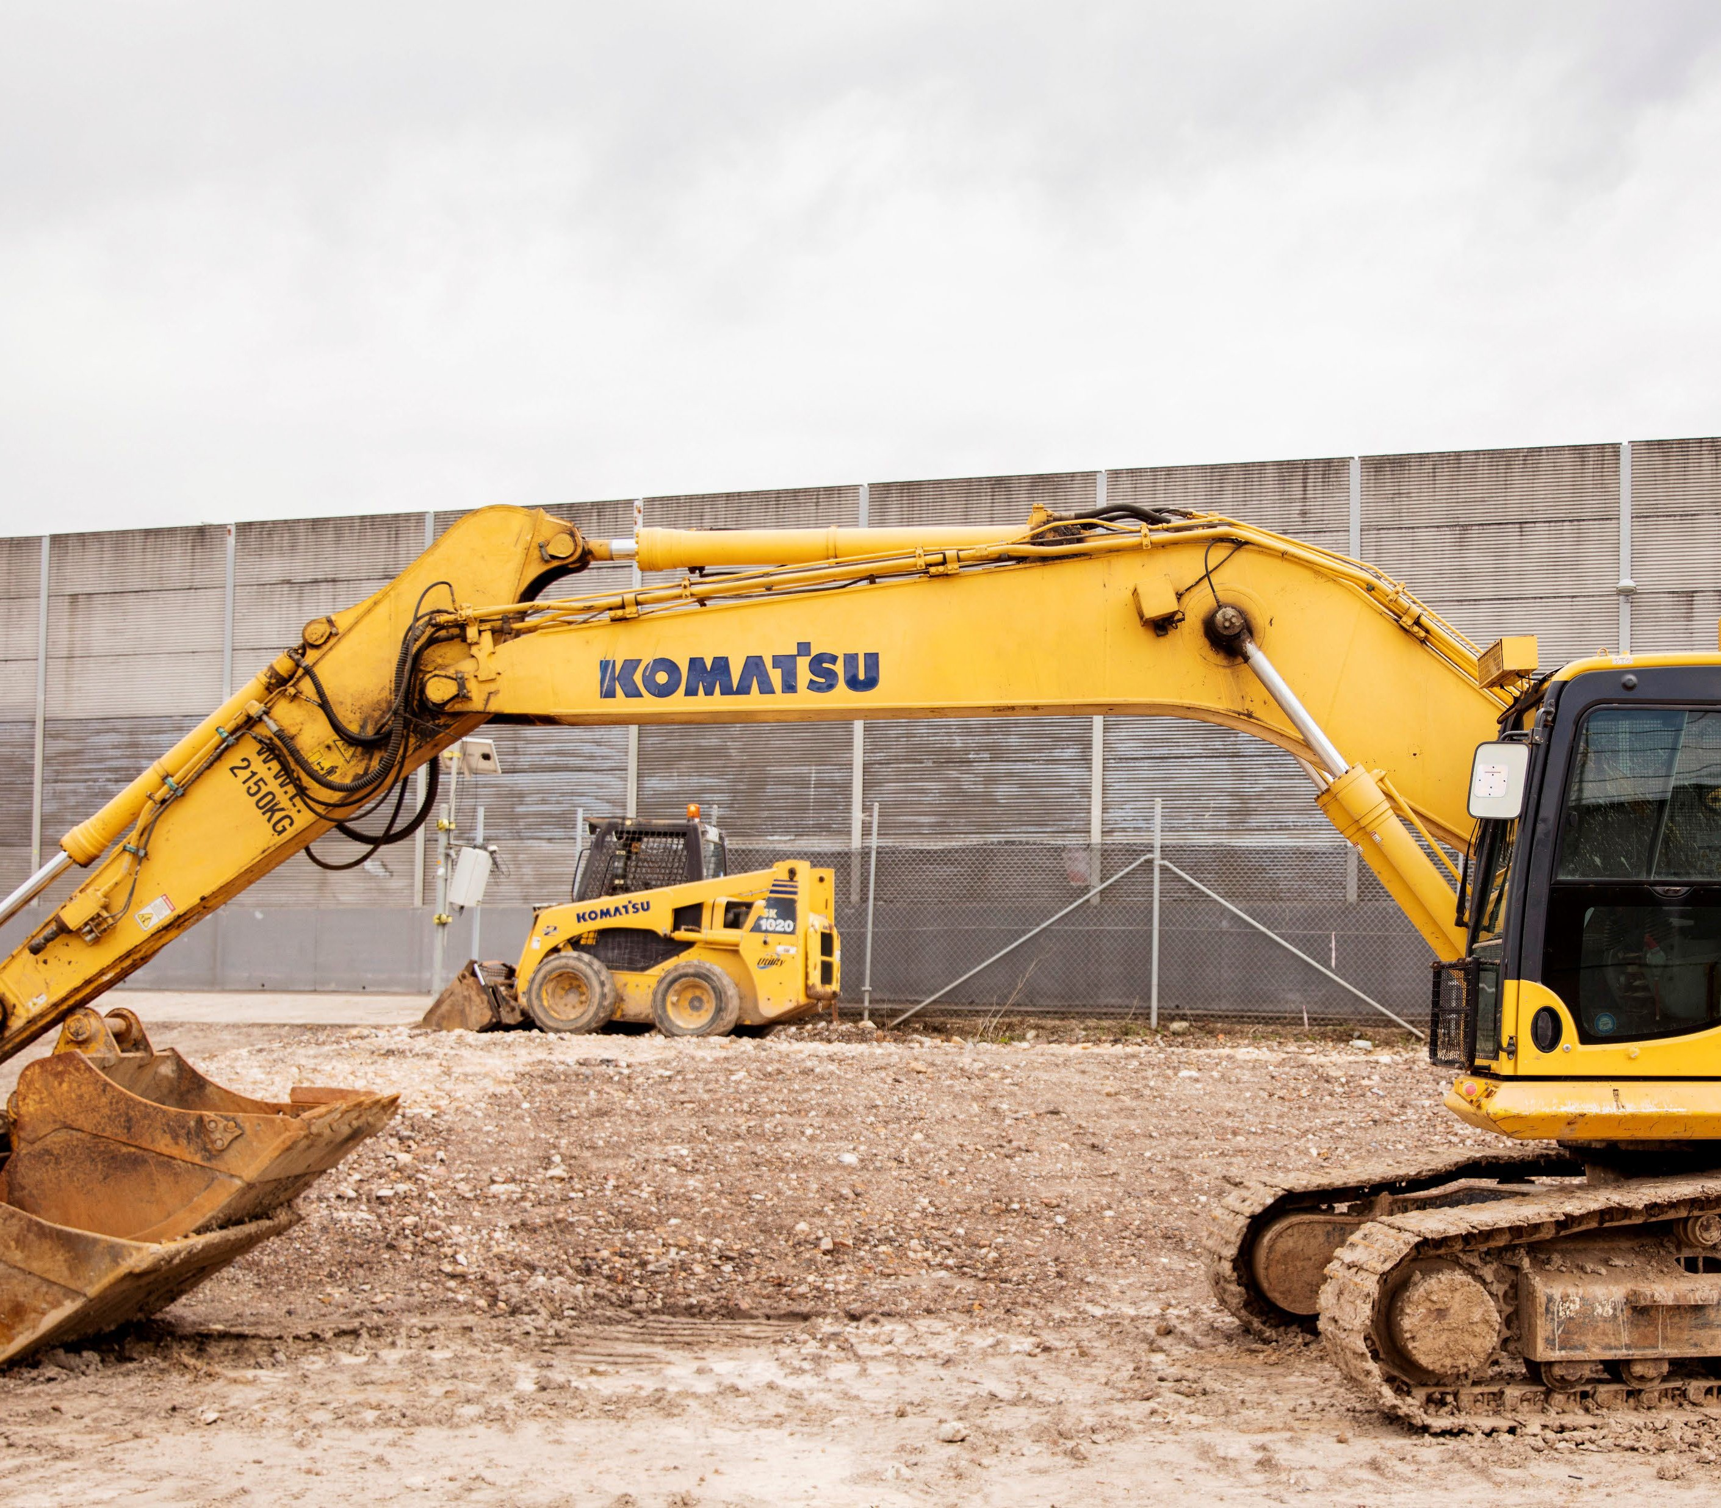

* Plan work so that mobile plant is not required on site.
* Schedule work so plant and people are not working in the same area at the same time.
* Plan work to remove or limit the need for plant to operate in reverse.
* Use physical barriers to isolate plant/people interactions.
* Use engineering controls such as cameras and proximity detection devices.

Scan to learn more.