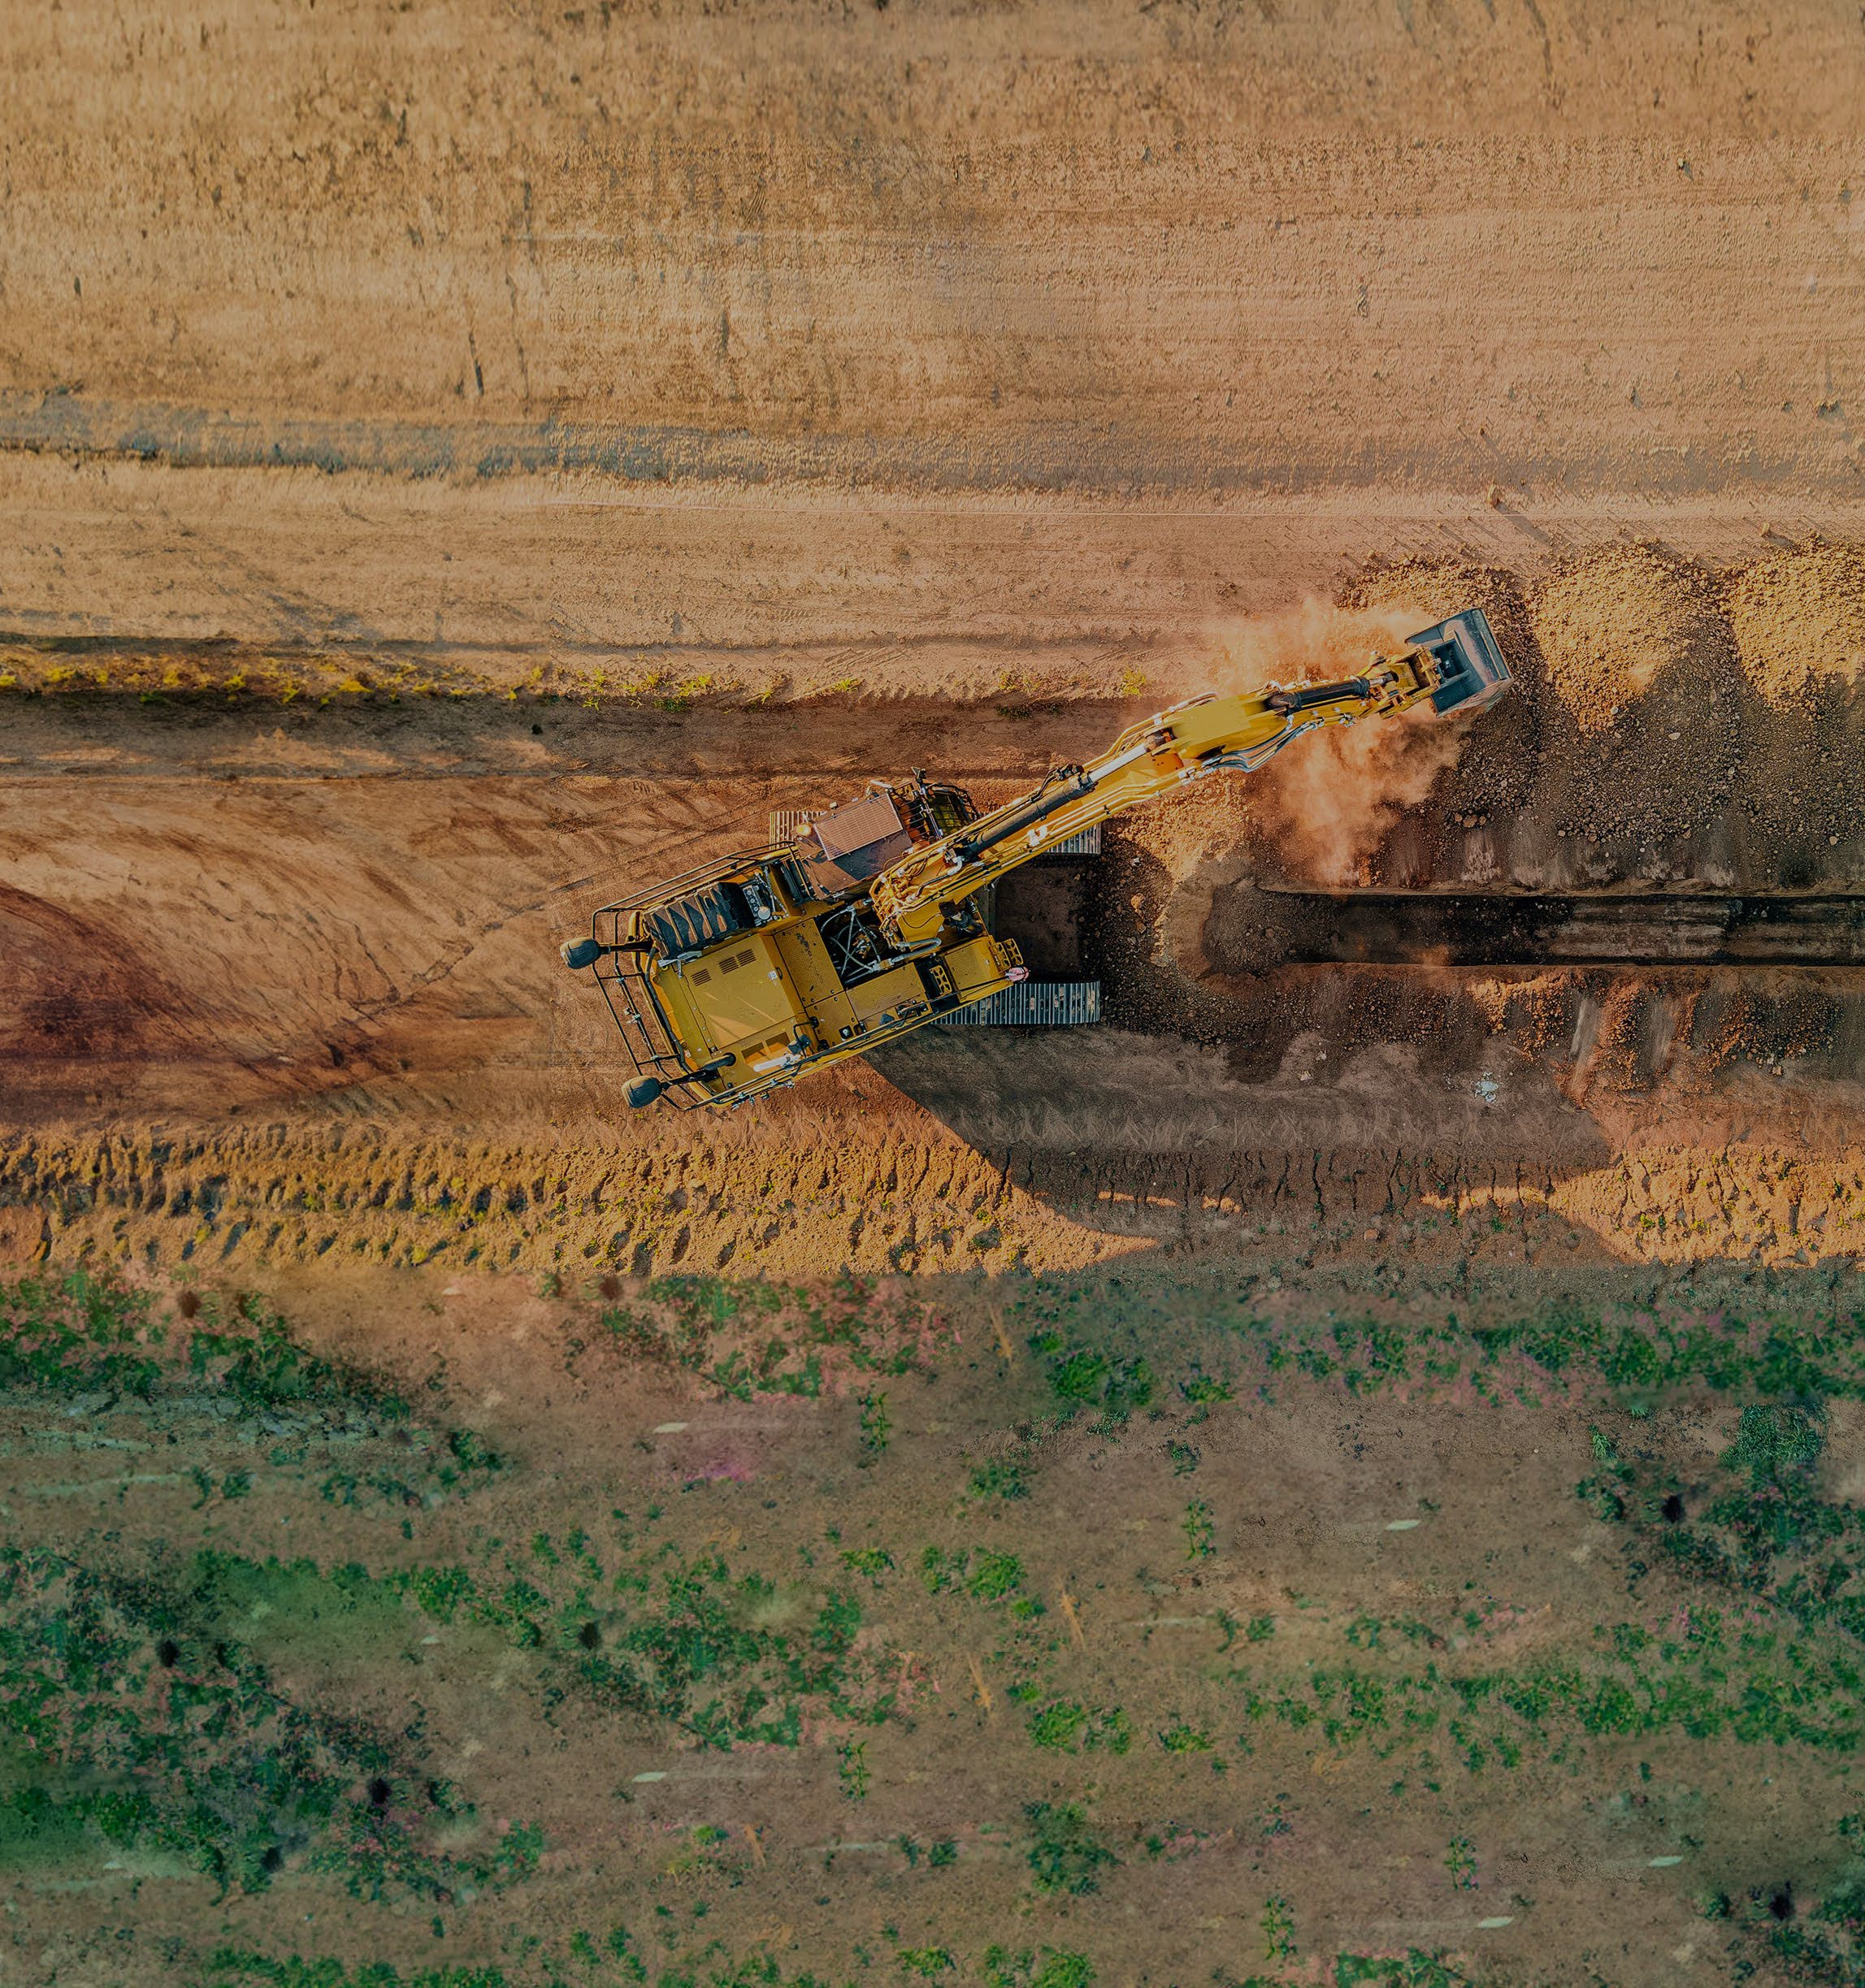

###### 

###### **Keep people and other vehicles away from operating plant.**

Establish exclusion zones using physical

barriers to separate people and plant .

Scan to learn more.