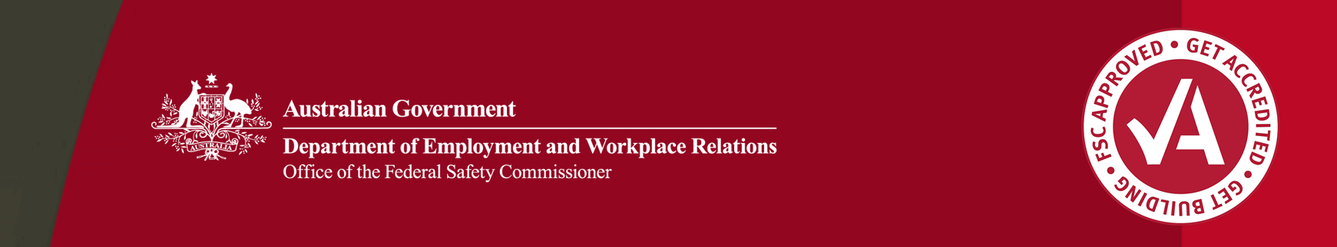

Fact Sheet – Corrective Action Reports (CARs) and the auditing process

As part of the Work Health and Safety Accreditation Scheme (the Scheme), companies are required to undergo audits to become accredited and to maintain accreditation. Audits are undertaken against the Federal Safety Commissioner’s Audit Criteria (the Criteria). Where a company’s documented Work Health and Safety Management System (WHSMS) does not meet the Criteria, or a company does not follow its safety system a Corrective Action Report (CAR) will be raised. This fact sheet outlines what constitutes a CAR, how companies should address them, and how a company can dispute a CAR.

# What is a corrective action?

A CAR is a finding made by a Federal Safety Officer (FSO) during an audit that a company’s WHSMS fails to meet the requirements of the Criteria and/or the company has not followed its WHSMS.

When a CAR is raised, the company needs to take corrective action to ensure its WHSMS fully meets the Criteria and is being implemented on site.

# What types of corrective actions are there?

There are two levels of CARs that can be raised at an audit by an FSO.

1. **A major non-conformance CAR** is raised where:

* A company’s WHSMS contains no documented process or system which meets the Criteria, or
* the company’s WHSMS fails to meet the Criteria in a substantial way, or
* there is no evidence a company’s WHSMS is being implemented onsite, or
* a company has failed to implement its WHSMS onsite in a substantial way.

A CAR will not be raised where a company’s WHSMS meets the Criteria, but no evidence of implementation is available because the relevant work has not yet been undertaken onsite.

1. **A minor non-conformance CAR is raised** where:

* a company’s WHSMS fails to meet the Criteria in a minor way, or
* a company has failed to implement its WHSMS onsite in a minor way.

# Opportunity For Improvement

An Opportunity for Improvement (OFI) is a suggestion made by a FSO to a company to further improve a WHSMS which meets the Criteria that is being fully implemented on site. An OFI will not be raised if a non-conformance with the Criteria is identified.

# Companies are not required to adopt or close out OFIs. They are suggested improvements only.

# How should corrective actions be addressed?

Companies are required to take remedial action to address CARs raised at audits.

Companies must provide the OFSC with an Action Plan detailing the steps it will take to update safety systems or onsite practices to address all CARs. The Action Plan must specify who is responsible for specific actions to address the CAR by a specified date. Companies should submit an Action Plan to the OFSC within 30 days of an audit report being released to a company.

Action Plans are reviewed by the OFSC. Companies should take prompt action to address the CAR. The OFSC will contact a company if it is concerned proposed actions to address a CAR are inadequate.

In some cases, the OFSC may also request evidence that items listed in an Action Plan have been completed. A company will be advised specifically if this is required.

This fact sheet was last updated 20 October 2023. The OFSC has prepared this fact sheet for general information only, and it does not replace professional advice. This fact sheet is derived from a variety of sources and has been prepare without taking into account your individual objectives, situations or needs. You should consider your personal circumstances, and if appropriate, seek independent legal, financial or other professional advice before acting. The OFSC has endeavoured to ensure the currency and completeness of the information in this fact sheet at the time of publication; however, this information may change over time. The OFSC expressly disclaims any liability caused, whether directly or indirectly, to any person in respect of any action taken on the basis of the content of this fact sheet.

The OFSC will review open CARs at a company’s next audit where it is expected the remedial action to address the non-conformance will have been completed such that the CAR can be closed. A failure to close CARs at subsequent audits is a trigger for compliance action against the company.

If a company is unclear on any aspect of the audit report a representative should contact its nominated OFSC Audit Officer as soon as possible to clarify.

# What if a company does not agree with a CAR?

FSOs will highlight at audit where they intend to issue a CAR. If after discussing non-conformances with the FSO during the audit, or after seeing the audit report, a company disagrees with a CAR, they should contact their nominated OFSC Audit Officer to request a review.

A review will be undertaken by an OFSC official (not an FSO) based on the information presented by the company at the time of the audit.

A review will either confirm a CAR, vary it, or set it aside. The outcome of a review will be communicated to the company.

If the review confirms the CAR, the OFSC will work with the company to ensure it understands the criteria requirements and the non-conformances identified.