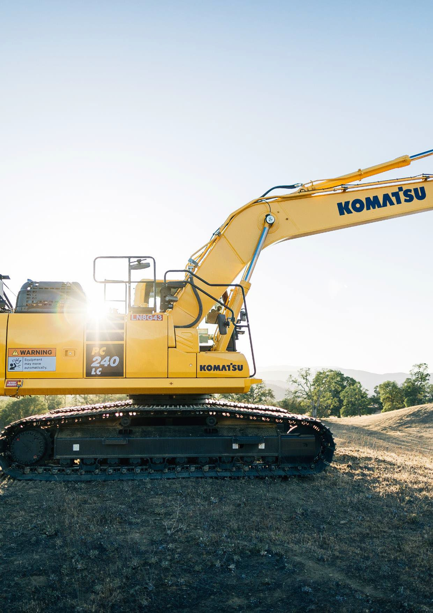

**Toolbox Talk**

**MOBILE PLANT –** MANAGING BLIND SPOTS

Scan to learn more.



# FACTS

**Presenter guide**

* Find a quiet space. Check that everyone can hear you and each other.
* This Toolbox Talk can be delivered in its entirety. Or, depending on the time available, audience and focus, each page can be delivered as separate smaller Toolbox Talks.
* Ask your workers to engage in discussion by sharing stories and asking questions.
* Consider giving a practical demonstration or show relevant photos, videos or diagrams.
* Print out the last page of this Toolbox Talk. Share as a handout and post on noticeboards.

**MOBILE PLANT: MANAGING BLIND SPOTS**

* One of the most common causes of incidents with mobile plant is when workers or members of the public approach the equipment while it is in operation.
* The Office of the Federal Safety Commissioner’s (OFSC) Hazard 2020 Campaign reported 121 mobile plant-related incidents from 2017-2019, with 37% being life-at-risk events. Of the 121 incidents, 40% were related to plant striking a person or another object.
* Generally, a person when stationary has a field of view of 180o horizontally, and 130o vertically, in good conditions. Outside the visual field we need stimulus to make us turn our head and look in that direction. A good stimulus when working around mobile plant could be a flashing/pulsating light, a distinct and clearly audible alarm, or a combination of both.
* All vehicles and mobile plant have blind spots. Where complete segregation between people and plant is not possible, operators and pedestrians need to continually monitor the movement of mobile plant within the hazard zone.
* Each item of mobile plant has different blind spots and vision shadows. Awareness of their line-of-sight limitations is required. The height, width and length of mobile plant may affect the extent and number of blind spots.
* Mirrors may reduce blind spots – but do not eliminate them. Cameras are also becoming more common but can also have ‘blind spots’ and rely on the operator to check them if they are to be an effective control.

# MESSAGES

* The closer you get to an item of operating plant, the more likely you will enter its blind spot.
* The movement of mobile plant is a hazardous activity. People and other items of plant need to be separated from operating mobile plant to avoid them accessing blind spots.
* Workers should never enter exclusion zones established for operating mobile plant.
* If you must approach operating plant, never assume the plant operator has seen you – always make positive contact (communication) with the operator (e.g., by voice, a radio or by signalling). Seek confirmation from the spotter if available. Wait until you have the operator's confirmation and for the mobile plant to be positioned in a safe stand down position before approaching.
* For many types of plant, blind spots can be larger than the operator’s actual field of vision, significantly limiting an operator’s visibility. Only ever approach plant from a safe approach angle where the operator has a clear view of you.
* Construction work, in areas where there is any movement of powered mobile plant, is high risk construction work. A Safe Work Method Statement (SWMS) is required to be prepared prior to the work commencing.
* The hierarchy of controls must be applied when establishing suitable blind spot controls. Other information sources to consider include the Original Equipment Manufacturers (OEM) manual and the plant risk assessment.
* Site rules and site-specific processes relevant to the works must be reviewed and followed.

**DISCUSSION QUESTIONS AND ANSWERS**



|  |  |
| --- | --- |
| **DISCUSSION**  One of the most common causes of incidents is when workers, members of the public or other items of mobile plant approach an item of mobile plant while it is in operation. | |
| **QUESTION**  What can be done to prevent people from being hit by an item of mobile plant? | **ANSWERS INCLUDE**   * Establish exclusion zones, using physical barriers, to segregate people and plant. * Make positive communication with the operator before approaching. * Use mirrors, cameras and detection systems (where fitted) to indicate the presence of a person/plant near the plant. * Use safe-to-approach beacons (where fitted on plant) to know when it is safe to approach. * Have the machine stand down to a safe position and if a person is to approach. |
| **DISCUSSION**  Mobile plant can be equipped with many devices that help reduce blind spots. These should never be solely relied upon as there can be other factors that introduce blind spots. | |
| **QUESTION** | **ANSWERS INCLUDE**   * Behind the cabin frame, i.e., Roll Over Protection, Falling Object Protection (ROPS/FOPS) * Behind the boom arm position (where relevant) * Out of the view of mirror(s) * Directly in front and behind the machine/cabin * Behind a bucket/attachment * Behind a load |
| Where are some common blind spot locations  on mobile plant? |
| **DISCUSSION**  Even if a spotter is present, no person or other item of mobile plant should approach any mobile plant when it is operating. Always establish positive contact (communication) with the plant operator before approaching operating mobile plant. | |
| **QUESTION** | **ANSWERS INCLUDE**   * Hand or flag signals * UHF Radio communication * Verbal interaction * Eye contact followed by confirmation by the operator, e.g., the plant is moved to its stand down, safe to approach position. |
| What are some ways that you can make positive contact with a plant operator? |



The diagrams below show examples of blind spots on various items of mobile plant.

**BLIND SPOTS: ONE OF THE LEADING CAUSES**

**OF INCIDENTS**

Blind spots can change depending on other factors including, attachment/bucket position, load positions, surrounding structures, weather conditions and the position of the plant and other workers.

Prior to commencing plant movements, it is essential that an operator, person conducting a business or undertaking (PCBU), or employer identify, check and confirm possible blind spots.

## DUMP TRUCK TRUCK BULLDOZER

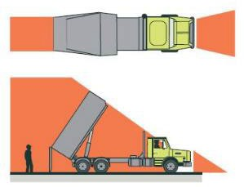 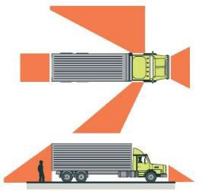 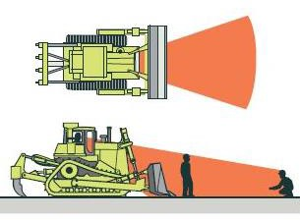

## EXCAVATOR ARTICULATED LOADER ARTICULATED ROLLER

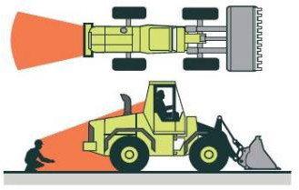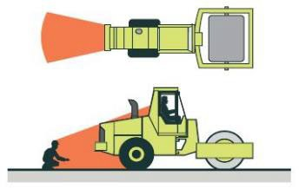

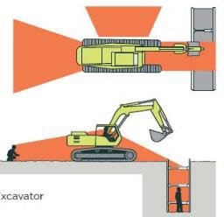

**TRACTOR SCRAPER GRADER NOTE**

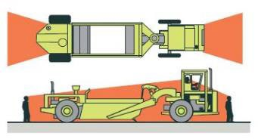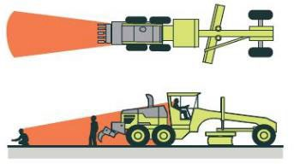While mobile plant may be fitted with controls that help reduce blind spots, e.g., mirrors, cameras, approach beacons and detection systems, this does not guarantee that the operator has seen them before making any movement of the plant.

Reference: [WorkSafe NZ–Safe reversing and spotting practices](https://www.worksafe.govt.nz/topic-and-industry/vehicles-and-mobile-plant/site-traffic-management/safe-reversing-and-spotting-practices/)

**SCENARIO** (OR SHARE A PERSONAL STORY FROM THE TEAM)

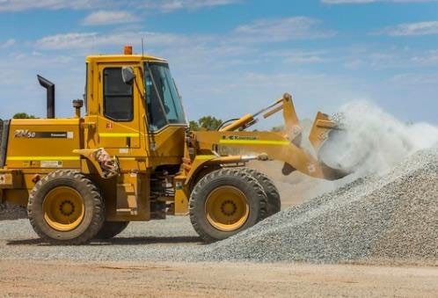

### A mechanic who needed to do some repairs on a front- end loader was fatally injured when he was struck and crushed by that loader as the operator was collecting a scoop from a roadside stockpile.

The loader operator thought he heard someone calling for him with a loud yell while he was driving forward.

They stopped and paused to listen for further calls – and then drove the loader in reverse to the area where they thought the call may have come from.

At the same time, the mechanic approached the rear left side of the front-end loader but was not seen by the operator due to the loader’s blind spots and physical obstructions in the work area, i.e., the gravel stockpiles.

Neither worker had radios or had received training on the equipment’s blind spots.

There was no written procedure or training for how pedestrians should make contact with the operator of this piece of mobile plant.

Example image for illustrative purposes only.

**ASK**

* **Do we have any new or inexperienced workers who need extra support or supervision?**
* **Do we have any mobile plant that is not suitable for the task or fit for purpose (in good working order)?**
* **Do we know if anything has changed or is likely to change from our original task plans?**

**QUESTION TO ASK WORKERS** WHAT CONTROLS WERE MISSING FROM THIS SITUATION?

**ANSWERS INCLUDE**

* Insufficient application of the hierarchy of controls to eliminate or isolate mobile plant from foot traffic, such as:
  + using a different type of mobile plant or conveyors, where possible
  + installing fixed or temporary barriers to segregate people and plant movement
  + establishing designated walkways, e.g., ground painted
  + fitting mirrors or widening passageways to minimise blind spots
  + limiting material storage heights or height of loads during movement
  + installing signage, e.g. No Foot Traffic.
* Installing safety devices in mobile plant where possible, e.g., backup cameras, sensors, warning spotlights, mirrors or alarms that can be heard above the noise, flashing safe to approach lights.
* Positioning workers to act as spotters in areas where there are blind spots.
* Having positive communication devices for people and plant, e.g., radios, phones.
* Developing and implementing a procedure for safely approaching mobile plant. This could include requirements for exclusion zones, positive communications, plant safety stand down positioning and angles of approach of mobile plant.
* Ensuring operators and other workers are trained and evaluated on all equipment blind spots at the workplace.
* Workers are supplied with and wear high visibility safety clothing.



**Information and resources**

Scan to learn more.

Scan to learn more.

**ACTIONS** (Safety and health above all else)

**MANAGING BLIND SPOTS ON MOBILE PLANT**

* **ESTABLISH** physical exclusion zones around items of operating mobile plant to prevent access to people and other items of mobile plant. Establish safe systems of work for plant and people interactions, considering legislative requirements, the hierarchy of controls and site-specific requirements.
* **EDUCATE** workers on the site about mobile plant blind spots and site rules for approaching mobile plant. Include an understanding of the various ways a piece of mobile plant may move so they can avoid.
* **CONFIRM** the competency of the plant operator. Use a trained and competent spotter when moving plant to help manage blind spots.
* **DO NOT ASSUME** the plant operator has seen you or knows you are approaching the mobile plant. Ensure you are positioned at a safe distance outside the mobile plant slew/movement zone. Make confirmed positive contact with the operator. Wait until the plant is in a safety stand down prior to approaching.
* **EXAMINE** what blind spots exist on mobile plant and whether controls such as approach beacons/flashing lights, sensory detection units, reversing beepers or mirrors can be fitted to the plant to assist in possible blind spot management.
* **APPLY** the hierarchy of controls when selecting suitable controls for the management of blind spots that preference ‘above the line’ controls in before ‘below the line’ lower-level controls.
* **TRAIN AND INDUCT** workers in the task risk assessment (i.e., SWMS) specific controls for the work activity. Wear high visibility clothing on the worksite.

**KNOW YOUR HEAVY METAL BY ASKING:**

* + Have we ensured our workers are skilled, educated and capable?
  + Are mobile plant operators trained and competent?
  + What site-specific conditions and environment do we need to consider and manage?
  + Have we separated people and plant?
  + Are our safe systems of work adequate and clearly communicated to all relevant personnel?
  + Is our mobile plant and equipment in good working order and fit for use?
  + Are emergency plans in place to manage instances where unwanted events occur?