### STAY SAFE

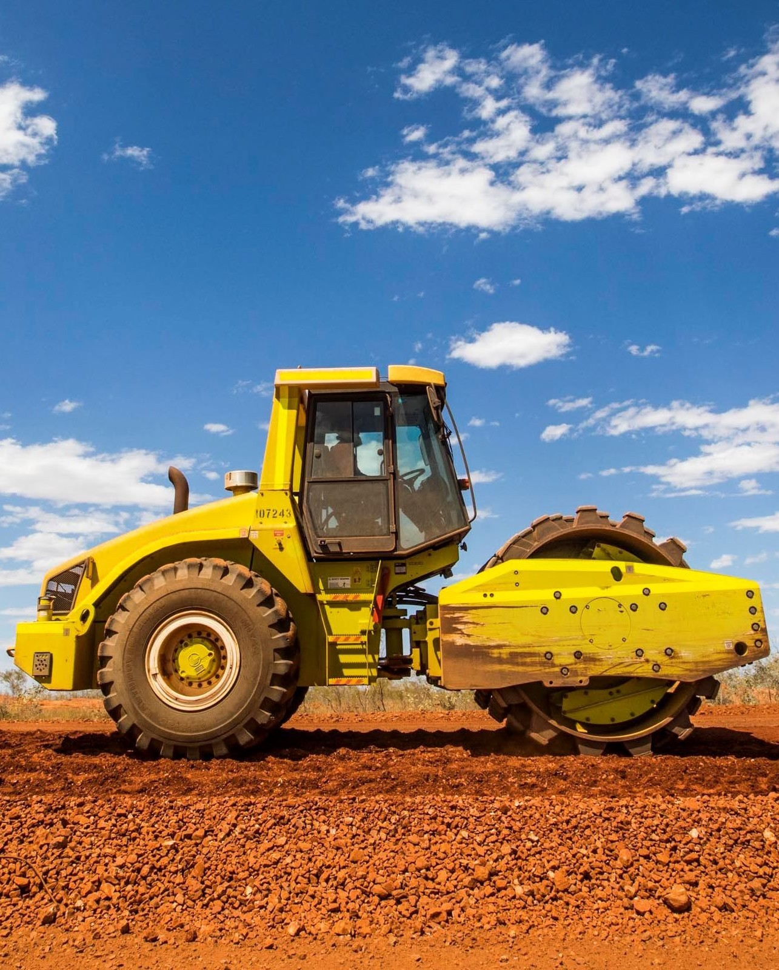

### WHEN YOU ARE

### WORKING ON

### OR NEAR

### MOBILE PLANT.

Scan to know more