Formal Notification of Changes to WHS Accreditation Scheme Reporting Requirements – June 2023

Under the Building and Construction Industry (Improving Productivity) (Accreditation Scheme) Rules 2019, Section 15(1)(e) the accredited person must comply with the reporting requirements notified to the person under subsection (2) from time to time. This is a formal notice of a change to the reporting requirements.

From 1 August 2023, the following changes to the reporting requirements of all companies accredited under the Work Health and Safety Accreditation Scheme (the Scheme) will take effect.

The updated Scheme incident reporting submission requirements are as follows:

PREVIOUS REQUIREMENTS
Incident Type | Timeframe |  | Project Type
 | Notifiable* | Non-Notifiable* | Scheme | Non-Scheme
Fatality | 48 hours | n/a | Y | Y
Lost Time Injury (LTI) | 48 hours | 3 weeks | Y | Y
Medically Treat Injury (MTI) | 48 hours | 3 weeks | Y | N
Dangerous Occurrence | 48 hours | n/a | Y | N

NEW REQUIREMENTS FROM 1 AUGUST 2023
Incident Type | Timeframe |  | Project Type
 | Notifiable* | Non-Notifiable* | Scheme | Non-Scheme
Fatality | 48 hours | n/a | Y | Y
Lost Time Injury (LTI) | 2 weeks | 2 weeks | Y | Y
Medically Treat Injury (MTI) | 2 weeks | 2 weeks | Y | N
Dangerous Occurrence | 2 weeks | n/a | Y | N

*A notifiable incident is an incident that is required to be notified under the relevant WHS legislation in the jurisdiction in which the project is being undertaken.

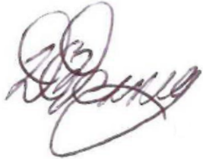

David Denney
Federal Safety Commissioner

30 June 2023

