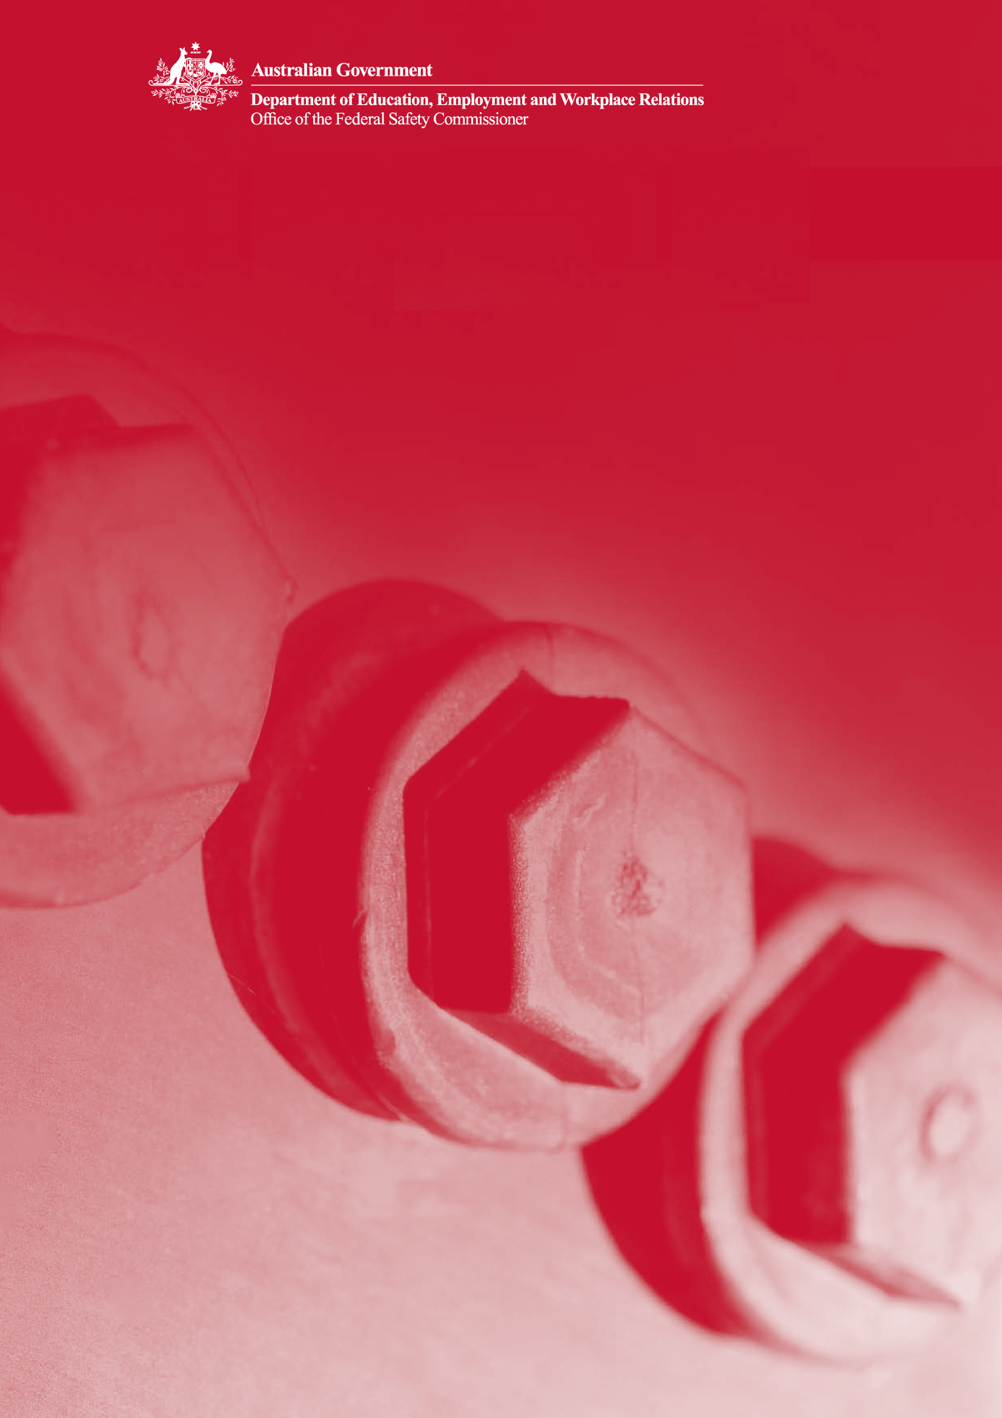

1 The Model Client Framework

The model client: Promoting safe construction

# **Model client self-assessment checklist**

## Level 1

|  | Minimal OHS processes in place  Few or no model client behaviours or initiatives |
| --- | --- |

## Level 2

|  | A3 Analyse OHS risks of project options |
| --- | --- |
|  | A5 Record risk information |
|  | A6 Develop the project brief |
|  | B2 Conduct design OHS reviews |
|  | B6 Include OHS in contract documents |
|  | B7 Set project OHS targets and KPIs |
|  | C2 Participate in site-based OHS programme |
|  | C4 Review and analyse OHS data |
|  | C5 Conduct OHS inspections/audits |
|  | D1 Evaluate project performance |

## Level 3

|  |  |
| --- | --- |
|  | A1 Appoint OHS team |
|  | A2 Develop project OHS Charter |
|  | A4 Undertake a technical feasibility study |
|  | A7 Establish design requirements |
|  | B1 Select safe designer |
|  | B9 Select safe contractor |
|  | C1 Approve project OHS management plan |
|  | C3 Review method statements, JSAs and other plans |

## Level 4

|  |  |
| --- | --- |
|  | B3 Review design documentation |
|  | B4 Review project cost |
|  | B5 Implement change management process |
|  | B8 Specify how OHS is to be addressed in tenders |
|  | D2 Perform project completion review |
|  | D3 Perform post-occupancy review |
|  | D4 Perform final review of plant/equipment |
|  | D5 Select safe maintenance providers |

## 

**Further information**

This booklet is the first in a series about clients promoting safe construction. Further information about the Model Client Framework is available from the Office of the Federal Safety Commissioner.

**FSC Assist Line:** 1800 652 500

**Internet:** www.fsc.gov.au

**Email:** [ofsc@dewr.gov.au](mailto:ofsc@dewr.gov.au)

ISBN (set) 978-0-642-32687-4 (print)

978-0-642-32693-5 (online)

ISBN 978-0-642-32627-0 (print)

978-0-642-32633-1 (online)

© Commonwealth of Australia 2008

This work is copyright. You may download, display, print and reproduce this material in unaltered form only (retaining this notice) for your personal, non-commercial use or use in your organisation. Apart from any use as permitted under the Copyright Act 1968, all other rights are reserved.

The Australian Government, its employees, officers and agents do not accept any liability of the results of any action taken in reliance upon, based on or in connection with this document. To the extent legally possible, the Australian Government, its employees, officers and agents, disclaim all liability arising by reason of any breach of any duty in tort (including negligence and negligent misstatement) or as a result of any errors and omissions contained in this document.

**Acknowledgements**

The authors would like to acknowledge that the project process map is based upon A Generic Guide to the Design and Construction Process Protocol developed by Kagioglou et al. (1998), The University of Salford, UK. Boxed and shaded descriptions of project phases are quoted directly from this Protocol. The Office of the Federal Safety Commissioner would like to thank Dr Helen Lingard, Dr Nick Blismas, Ms Tracy Cooke and Mr David Jellie from the School of Property, Construction and Project Management, RMIT University, who contributed to the development of this resource.