WORKCOVER NSW PERSPECTIVE ON ALCOHOL & OTHER DRUGS in the BUILDING & CONSTRUCTION INDUSTRY

Peter Robinson

Manager, Construction Team

Occupational Health & Safety Division

WorkCover NSW

April 2009

# CORE BUSINESS

Engage stakeholders to improve OHS and workers compensation outcomes

* Building strong ongoing relationships to share perspectives and partner with stakeholders
* Actively seeking and responding to stakeholder views
* Developing effective partnerships to provide a harmonised and whole of government approach to workplace safety and workers compensation.

# PREVENTION & RESPONSE

Applying an appropriate mix of information, assistance, education, advice, incentives and deterrents

* Building capability so that workplace health and safety risks are properly controlled
* Harmonised and practical workplace standards, information, testing, and workable solutions
* Working cooperatively to develop a workplace safety culture

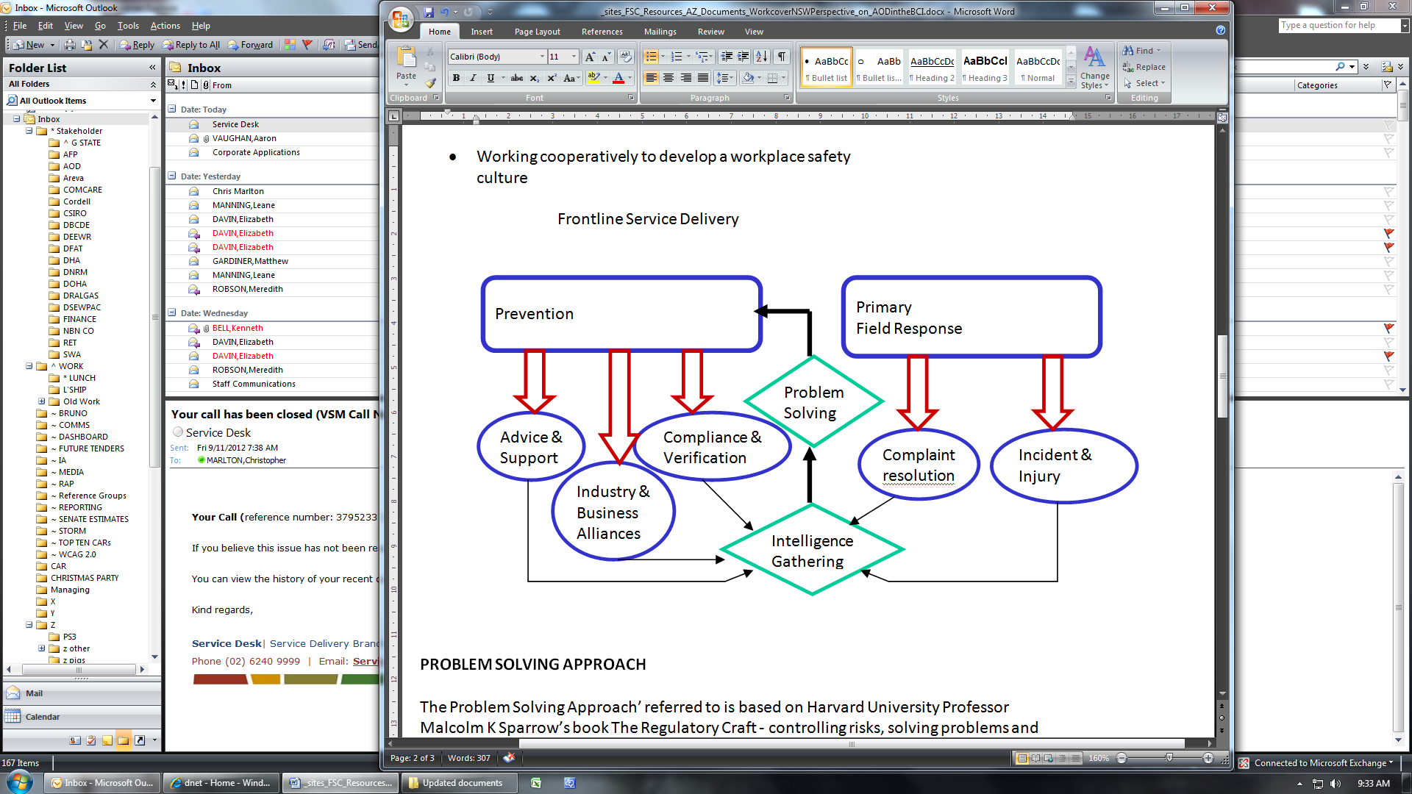

# PROBLEM SOLVING APPROACH

The Problem Solving Approach’ referred to is based on Harvard University Professor Malcolm K Sparrow’s book The Regulatory Craft - controlling risks, solving problems and managing compliance.

* A problem solving approach focuses an organisation’s resources more effectively on the root cause of problems and not merely the symptoms.
* The problem solving process has been incorporated into a step-by-step model that facilitates this approach to OHS Division's business

# PROBLEM SOLVING STEPS

Nominate potential problem for attention

* Define the problem precisely
* Determine how to measure impact
* Develop solutions or interventions
* Implement the plan
* Monitoring, review and adjustment
* Close project, allowing for long term, monitoring and maintenance

Frontline Service Delivery

Prevention

Primary

Field Response

Intelligence

Gathering

Problem

Solving

# Stakeholder Engagement

Industry Reference Groups

* Partnerships Alliances and Liaisons
* Industry Solutions Program
* Industry Forums
* Advisory Visits,
* Free Workshops
* Safety Bus

# AOD POLICY

Develop an AOD Policy in consultation

* Management Commitment
* Apply to All
* Raise awareness and educate
* Sets out unacceptable behaviour
* Counselling and Support
* Not one size fits all different risk pose different controls